**Project Report on**

**Online Art Gallery**

**Team Members:**

|  |  |  |
| --- | --- | --- |
| **Team Members** | **Team Members ID** | **Role** |
| Rajat Kohal (TL) | 1124656 | Developer |
| Beant Kaur | 1127119 | Software Tester |
| Harjot Kaur | 1126254 | Database Expert |
| Jaspreet Kaur | 1127647 | Front end Designer |
| Amandeep Kaur | 1122422 | Business Analyst |

Contents

Introduction 3

Application Design Methodology 3

Problem Statement 4

Magnitude of Problem 4

contributing Factors 4

impact of the Problem 4

Business Requirements 4-5

Proposed Solutions 5

Project Objective 5

Application of Tools 6

Evidence of learning through project Experience 7

Time Frame 8-9

Factors hinder the project ................................................................................................... 9

Functionality coverage 10-

Technical Designs.…………………………………………………………………………………………….. ……..10-45

Database Tables…………………………………………………………………………………………………………14-18

Web Page Designs……………………………………………………………………………………………………..19-43

Coding Principles..……………………………………………………………………………………………..…………..44

Coding Screenshots…………………………………………………………………………………………………..44-45

Quality Control Plan 46-48

Quality Assurance.……………………………………….……………………………………………………………… ..46

Test Plans…………………………………………………………………………………………………………………..46-48

Risk Management………………………………………………………………………………………………………….48-49

User Guide 50-51

Deployment Guide 52

Deliverable 53

Conclusion 53

Client Approval 53

References 54

Appendix 55-56

**Introduction**

Online Art Gallery is an online application to purchase and view paintings. This web application has the salient features which assist the admin to automate the manual tasks and maintain all records of art gallery. The primary stakeholder such as customer, seller and admin, all have their separate portals that can be accessed by inputting credentials. It provides the platform where seller can sell the paintings and customer can buy it. Beside this, Admin can manage customer, painting stock record, painting categories and transaction history.

The purpose of this project report is to provide the information about problem statement, requirements, solutions and their detailed functionality coverage. Further, it provides the information about used technologies and time frame which was followed during the project development. Lastly, it includes quality assurance, risk management matrix, deployment guide, deliverable, and conclusion.

**Application Design Methodology**

An investigation of web application plan system demonstrates that a huge level of data giving web applications is exact to improve result to getting from business issue to the arrangement under authoritative rules. (Russo, 1999) . We have used waterfall model which consists different phases to develop an effective web application.

The waterfall model is a sequential model utilized in framework advancement life cycle to develop an application with a direct and successive methodology.(Petersen, 2009)

These phases are:

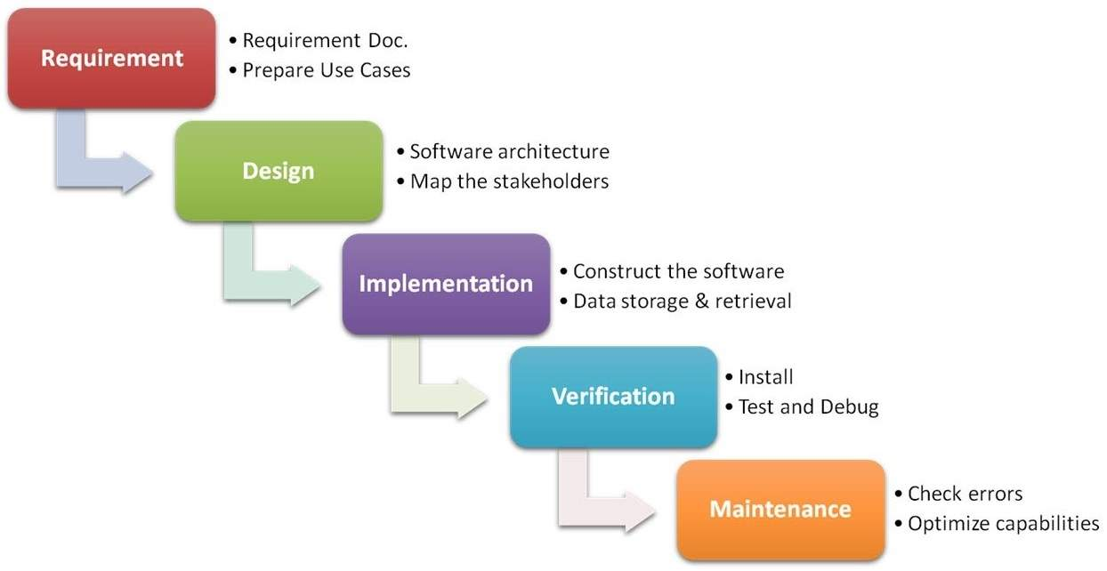

|  |  |  |
| --- | --- | --- |
| **Sr. No.** | **Phases** | **Tasks** |
| 1 | Requirement | Conducted Client meeting and brainstorming with team members to gather more data to understand the problem. |
| 2 | Design | Created web layout and finalize the complete design process. |
| 3 | Implementation | Develop the art gallery application using PHP and stored the data into the database. |
| 4 | Verification | Proper Testing techniques are applied such as Unit Testing for individual web page verification and Integration testing for complete project verification. Further, we have create the guide for installation and running the web application. |
| 5 | Maintenance | We have retest it and taken suggestions from client and followed quality standards to maintain the quality of project. |

**Problem Statement**

In this modern era, people are mostly preferred buying products via internet. There are numerous web application which are unhandy for the people to maintain their product details. However, Manual approach needs more efforts, time and resulting minimization of profitability. (Cinis, 2017) It is very hard to maintain the record of the paintings and to satisfy the customers need by using manual system. We have investigated data which was gathered by conducting client meetings, and studying literature review for identifying the Contribution factors and the magnitude of the problem.

**Magnitude of problem**

* Unsatisfied clients
* Decrease Productivity of the business
* Increase expenditure cost

**Contribution Factors**

* Need more employment for handling the customers.
* It may take leg and arm to maintain the records of painting stocks, Also affects the maintenance cost.
* It consumes time to manage the transactional record and to maintain the record on daily basis.

**Impact of the problem**

* Not presence online, leads unsatisfied customers
* Decrease Profitability

**Business Requirement**

We have worked with our client two minds technology as they want to sell the painting using online to get more profit for the organisation. However, they are selling art and gallery physically but the presence of business on internet is also essential for the growth of business and we have done proper research on this business problem. The created online art gallery application has features like show case all paintings in category, artist and each painting has a unique price list where customer can view paintings, purchase, view invoice and seller can sell in robust, quick and efficient manner. This web application is facilitating features to admin like maintain stock, manage categories, manage customers and view purchase history.

**Proposed Solutions**

|  |  |  |
| --- | --- | --- |
| Proposed Solution | Pros. | Cons. |
| **Paid Marketplace (Artfire, Artplode) -** community where people from around the globe come together to buy, sell and interact for art gallery products. | * forums and articles keep buyers and sellers in the contact * very less commission is charged | * Paid advertising * High Maintenance cost |
| **Web Platform (Faso) -** existing solutions for creating websites to show their artwork | * Supporting Staff * Designed templates are available | * Inflexible * Less third party services support. * Expertise knowledge require to maintain |
| **Art & Gallery web App –** Customized application as per the expectations of client. | * Customized Web APP * Easy maintenance * More reliable * Secure | * Time required to built * Complete Team Efforts |

**Project Objective**

1. To create an online web application to show cases the paintings and facilitates a feature of buying and selling.
2. It will be more helpful for keeping the record of ordered paintings and available paintings.
3. It is a web platform which provides a separate portal for seller, customer and the admin.

**Application of Tools**

**Client Side scripting technologies**

* **HTML5 :** We have used HTML5 latest version which is used for the creation of web pages
* **CSS3:** We have used Cascading style sheet for making web page more interactive look and feel.
* **JavaScript:** We used JavaScript to validate the user inputs.

**Salient Features of Client Side scripting technologies**

* Interactive web page creation
* Platform independent
* Latest versions

**Server Side scripting technologies**

* **PHP:** PHP is widely adopted because of open source. It is used for the development of dynamic web pages and web applications. It can be easily embedded with database.
* **XAMPP Server:** XAMP Server Stands for "Extensible, Apache, MySQL and PHP", The most important part of the XAMPP Server is Apache which is used to test web pages on a local machine’s web browser without publishing on the web server.

**Salient Features of Server Side scripting technologies**

* Supports Distributed application functionality
* Easier database creation
* Secured as compare to other programming languages.

**Data Base technology**

* **MySQL:** We have used MySQL database in our project because it is an open source database, robust and easy to use.

**Salient Features of Data Base technology**

* Open Source
* Scalable and flexible
* Modular design approach

**Evidence of learning through project experience**

We have created a separate portal for the seller, customer and the admin where admin has the complete right to view the complete details of the all stakeholders but the seller can view or manage its own specific details. We have found that the CURD is very important for the implementation of any module that’s why each module has the features to create, update, retrieve, and delete the module data.

|  |  |  |
| --- | --- | --- |
| **Sr. No.** | **Requirements** | **Is requirement fulfilled?** |
| 1 | Availability of admin, Seller and customer logins | Yes |
| 2 | Availability of add paintings | Yes |
| 3 | Admin can add categories | Yes |
| 4 | Customer can buy paintings | Yes |
| 5 | Implementation of Paypal payment gateway | Yes |
| 6 | Purchase history record | Yes |
| 7 | Display paintings categories wise and apply filter on paintings | Yes |

**Time Frame**

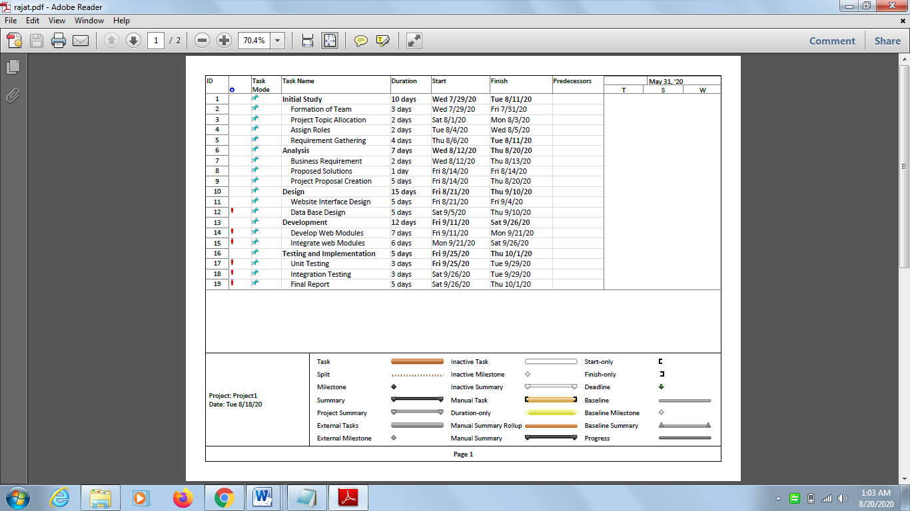

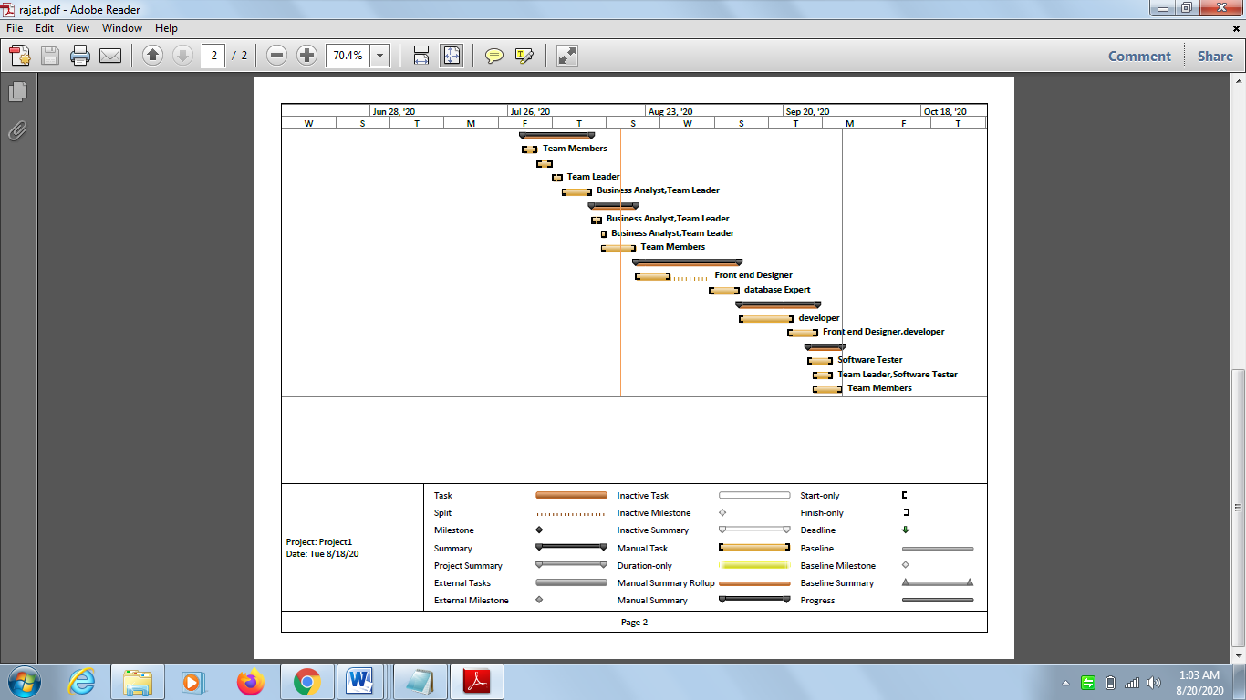 **Factors hinder the project**

Initially, we all team members have the knowledge of subjects but this is the first experience for us to work as a team and to develop the project under the guidance of the client and professor, It was very difficult to manage the project via online initially but there after we have learned how we can distribute the tasks among team members to accomplish the tasks and all team members has worked very efficiently to complete the project in given time constraint.

**Technical Designs**

A technical designs describes a solution to a given business problem. It is a “design blueprint”, for a web application. (Chao, 2006)

We have created class diagrams, DFD and Use case Diagrams to visualise the problem.

**Class Diagram**

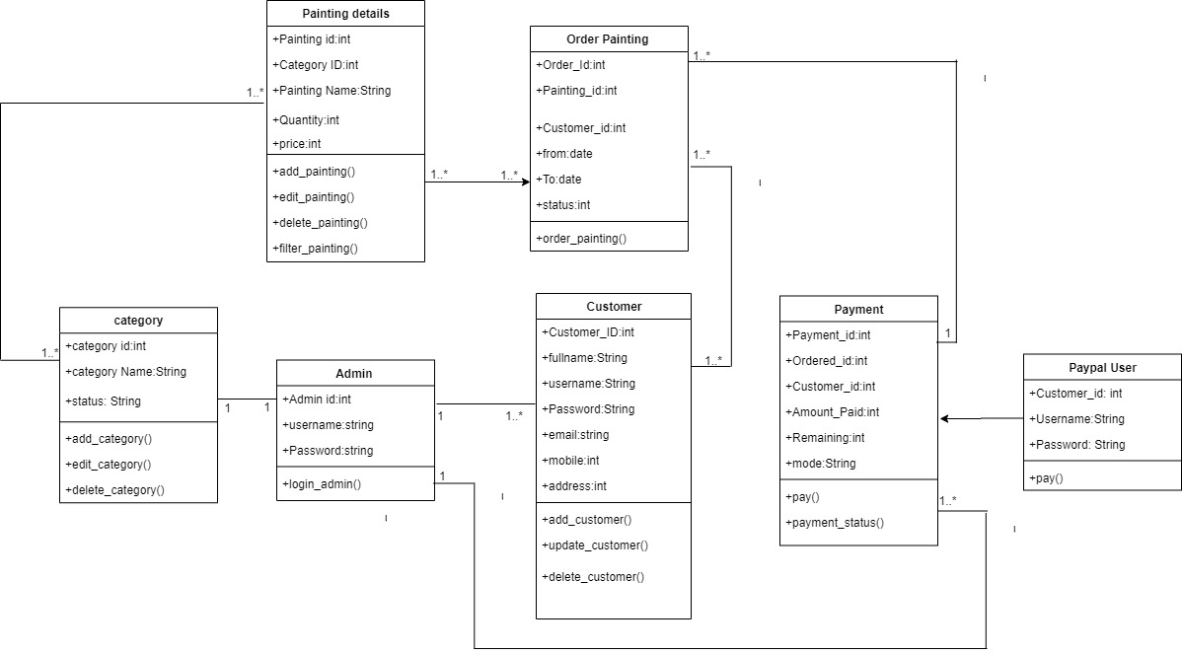

**Use Case Diagram**

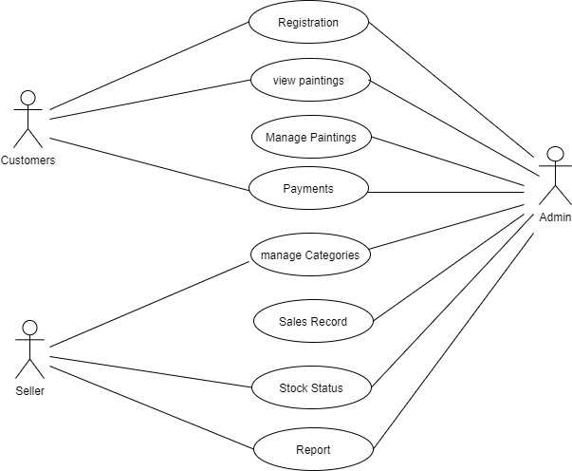

**Customer DFD**

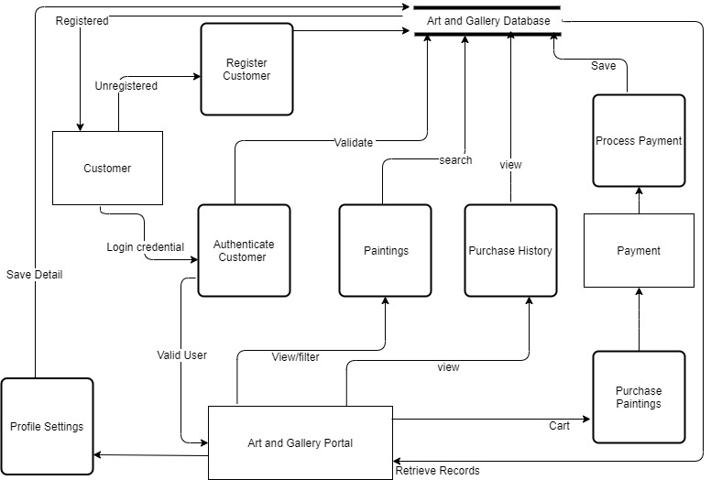

**Admin DFD**

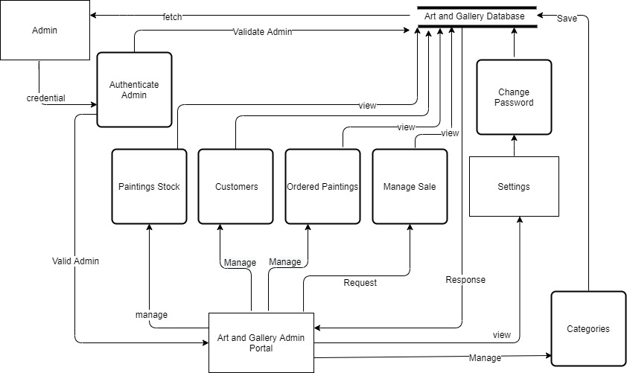

**Data Base Tables**

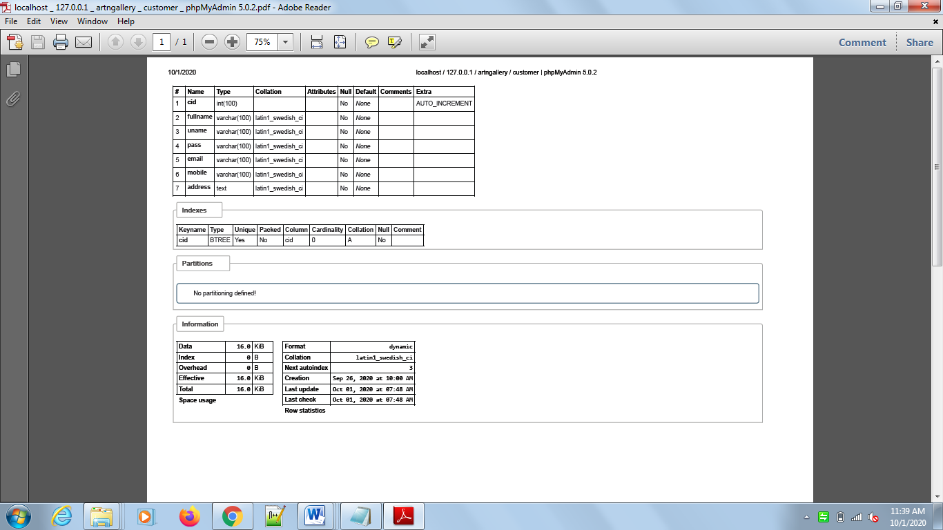

**Figure 1: Customer Table:** This table is used for storing customer data.

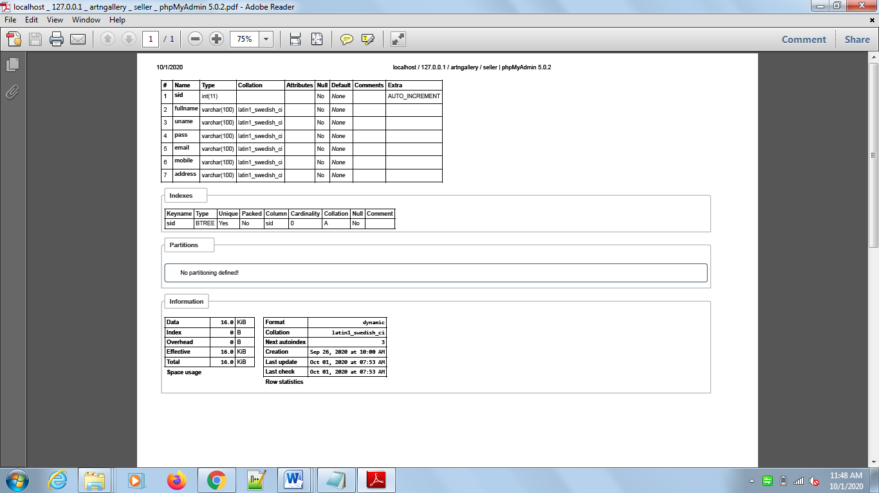**Figure 2: Seller Table:** This table is used for storing seller data.

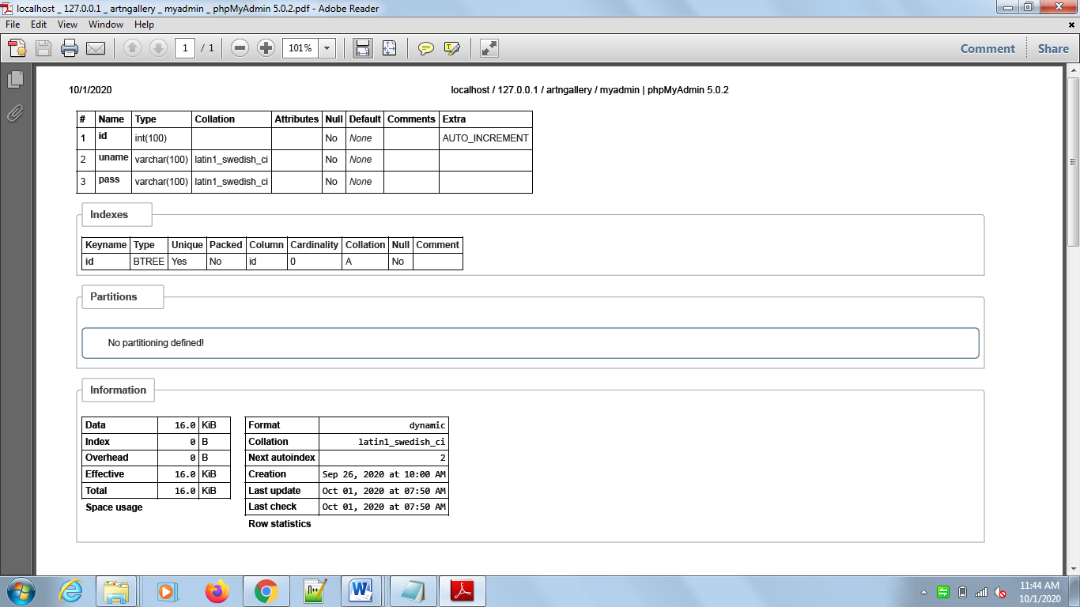

**Figure 3: Myadmin Table:** This table is used for storing admin record.

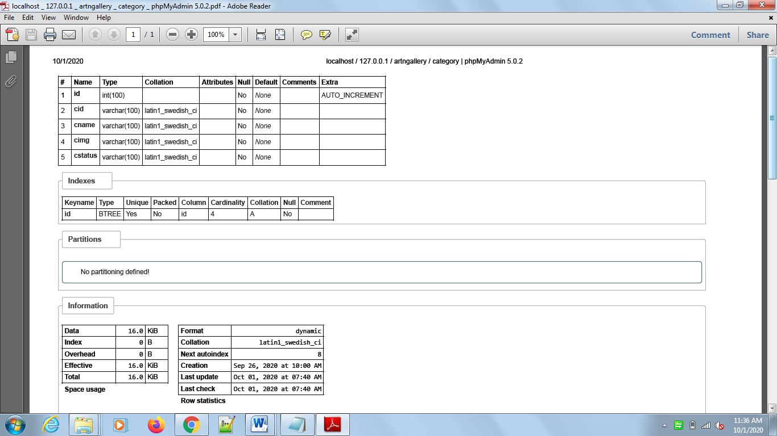

**Figure 4: Category Table:** This table is used for storing Category record of paintings.

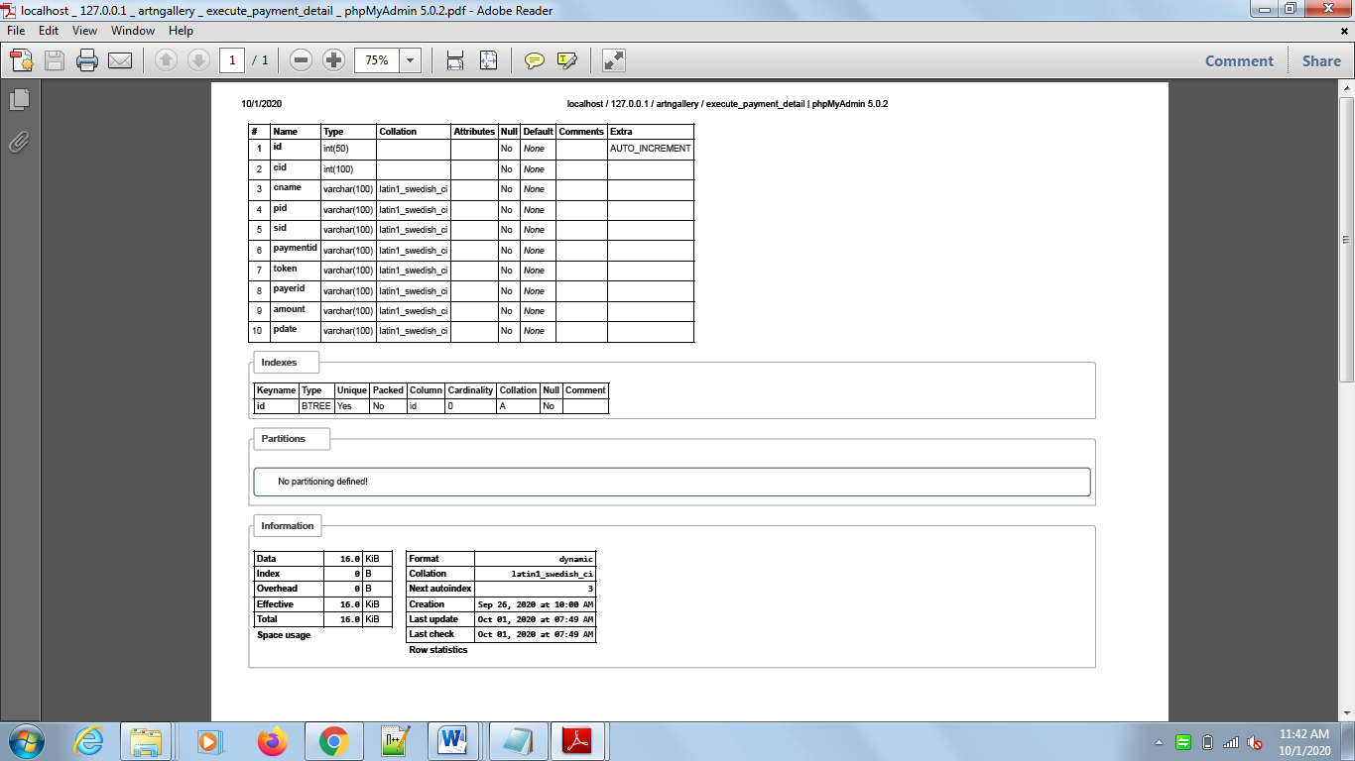

**Figure 5: Execute Payment detail Table:** This table is used for storing Payment record of sold paintings.

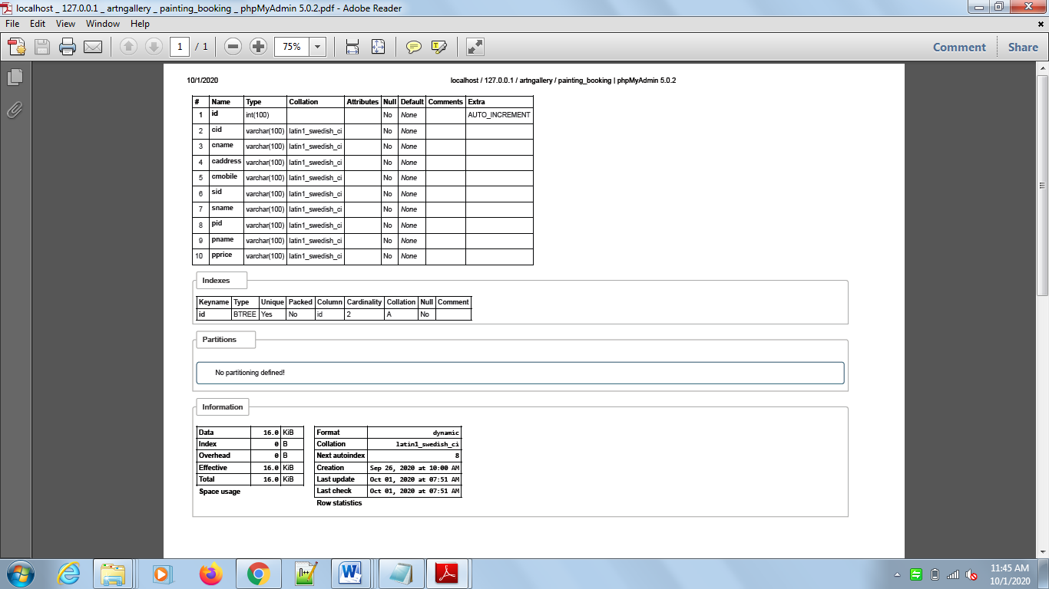

**Figure 6: Painting Booking Table:** This table is used for saving the record of ordered paintings.

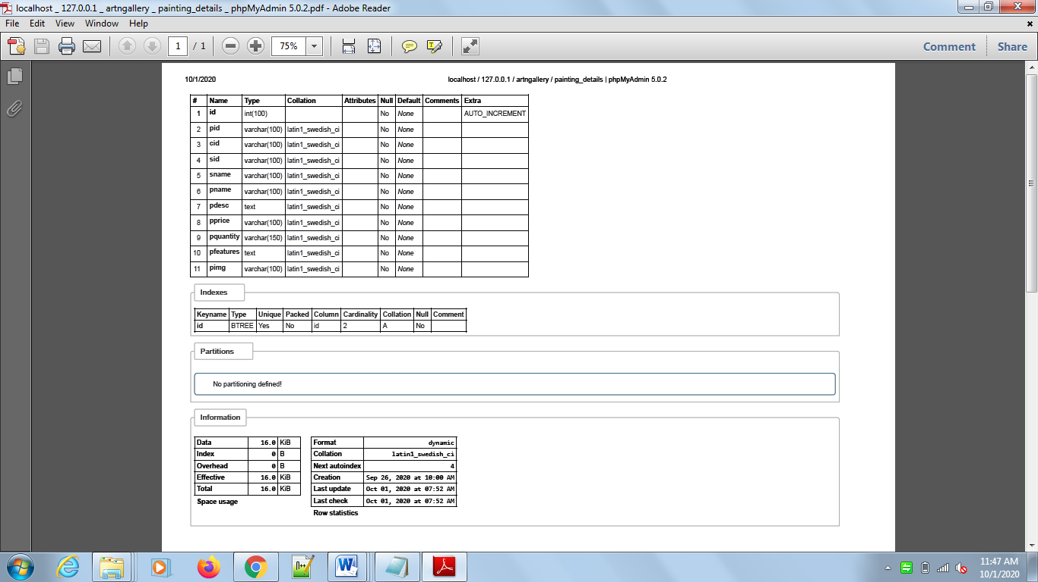

**Figure 7: Painting details Table:** This table is used for saving the detail of paintings.

**Webpage Designs**

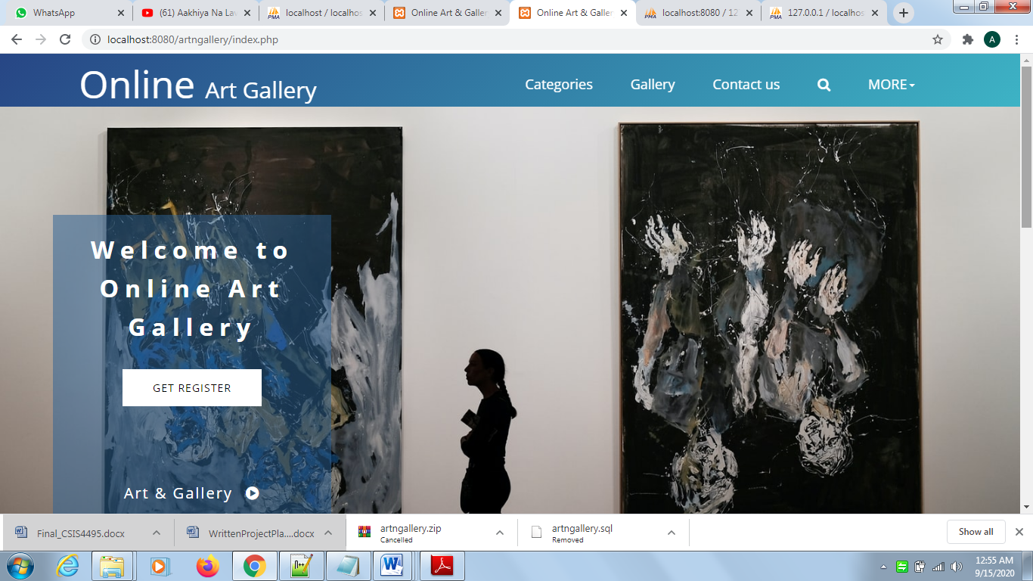

**Figure 1: Index webpage:** This is the first web page will be shown when any user will access the web application.

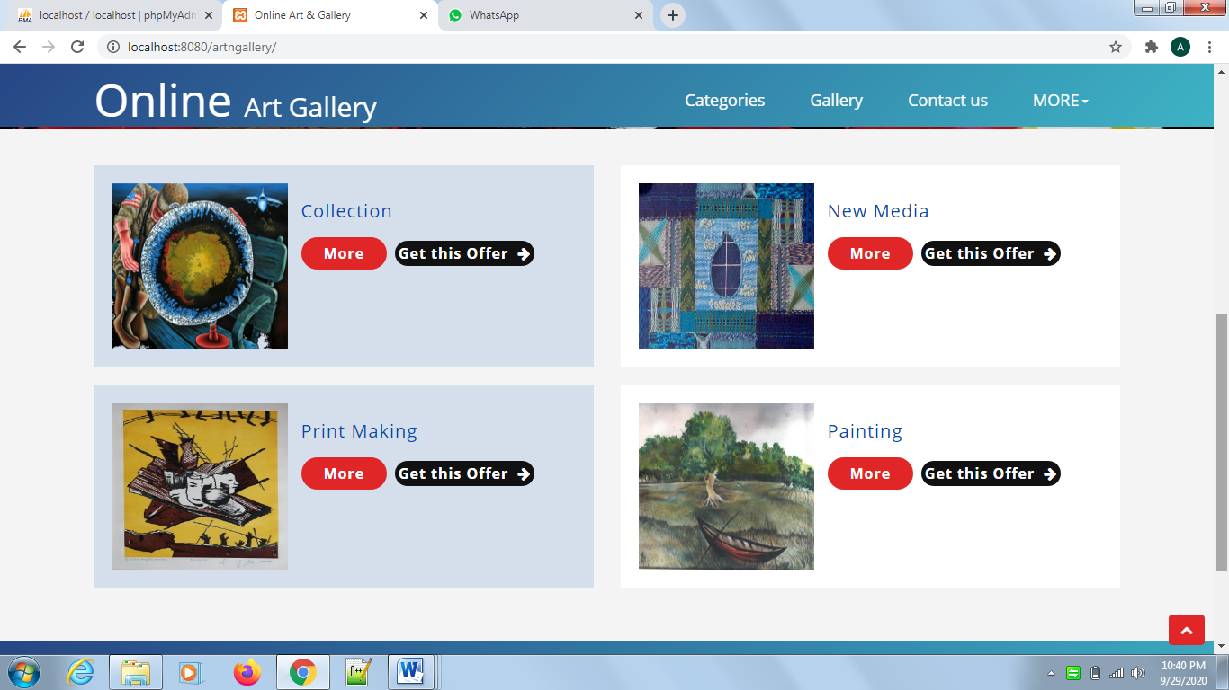

**Figure 2: Categories on Index webpage:** The list of all categories will be appeared on the front webpage of Online Art Gallery; these categories are dynamic which means can be updated from the admin portal.

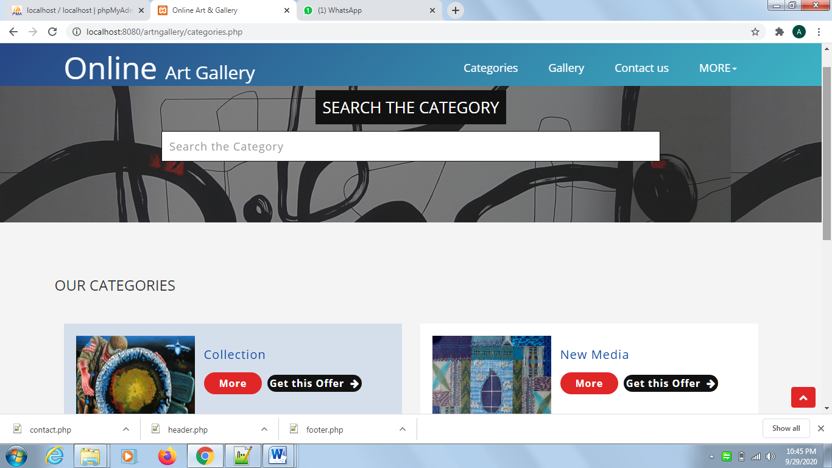

**Figure 3: Categories webpage:** The entire categories list will be shown on this web page where the customer can view the relevant painting by clicking on the more option and the all paintings of that category will be displayed. Also, Search bar is useful for searching any category by inputting characters.

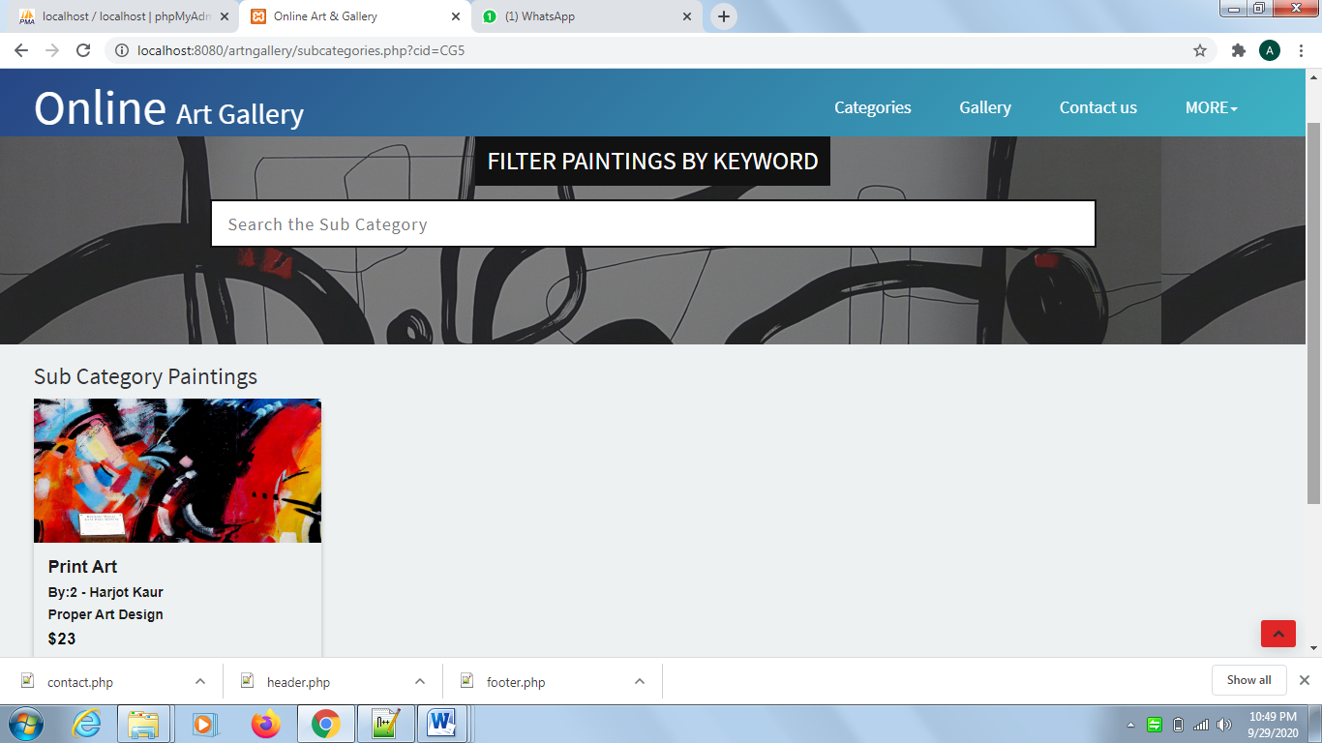

**Figure 4: Sub categories webpage:** This web page will be appeared when the customer click on the more option of the categories. All painting of that category will be shown and Customer can filter it using filter option.

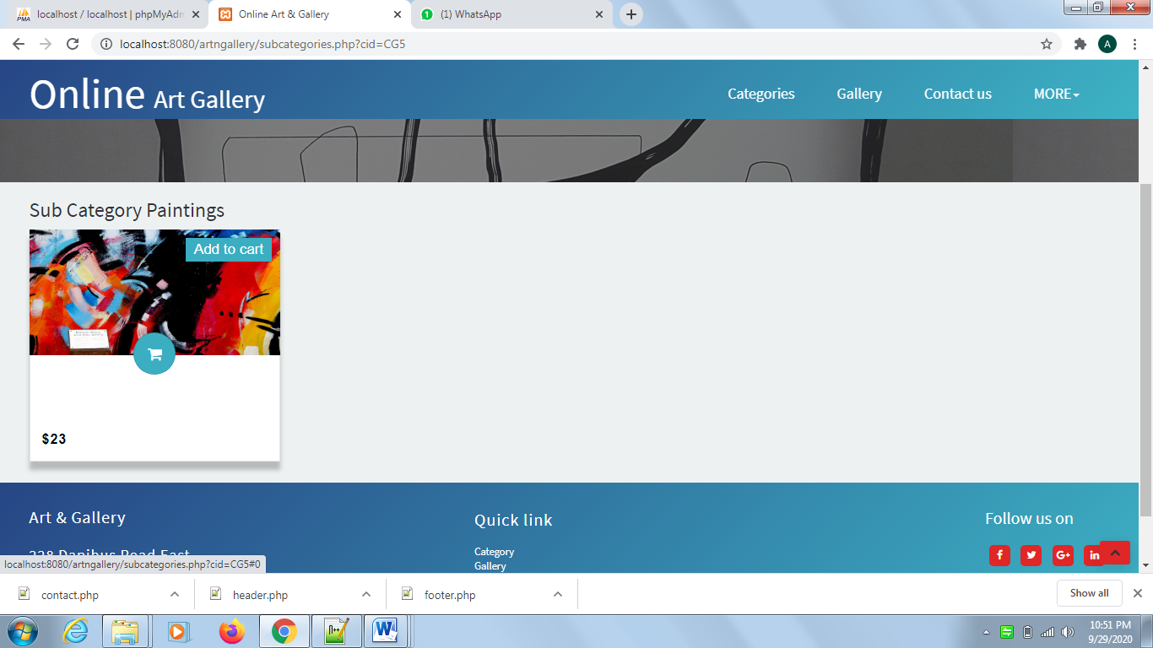

**Figure 5: Add to cart option:** on hover, Add to cart icon will be appeared and customer can click on cart icon for adding painting into cart.

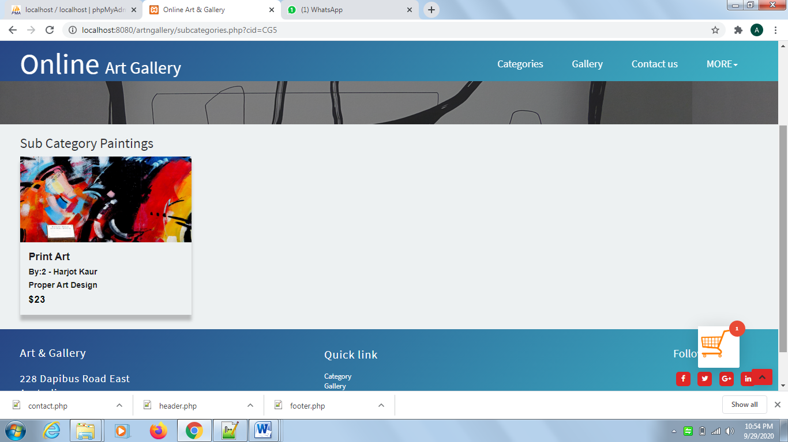

**Figure 6: Add to cart bucket:** By clicking on the add to cart icon, The cart bucket will be appeared on same page.

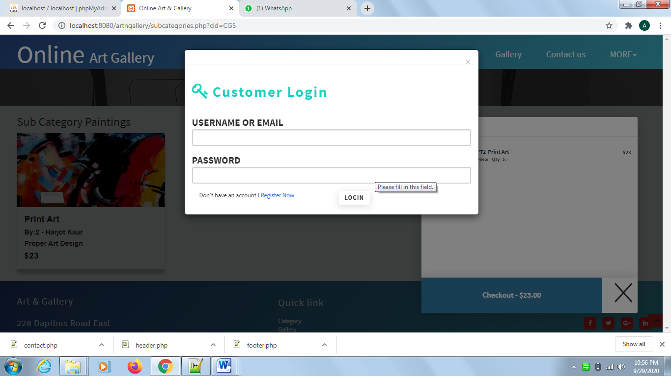

**Figure 7: Add to cart Checkout:** After adding painting, customer can decide whether he want to proceed or not. If yes, need to input customer credentials or need to sign up as customer.

**Figure 8: Checkout cart webpage:** 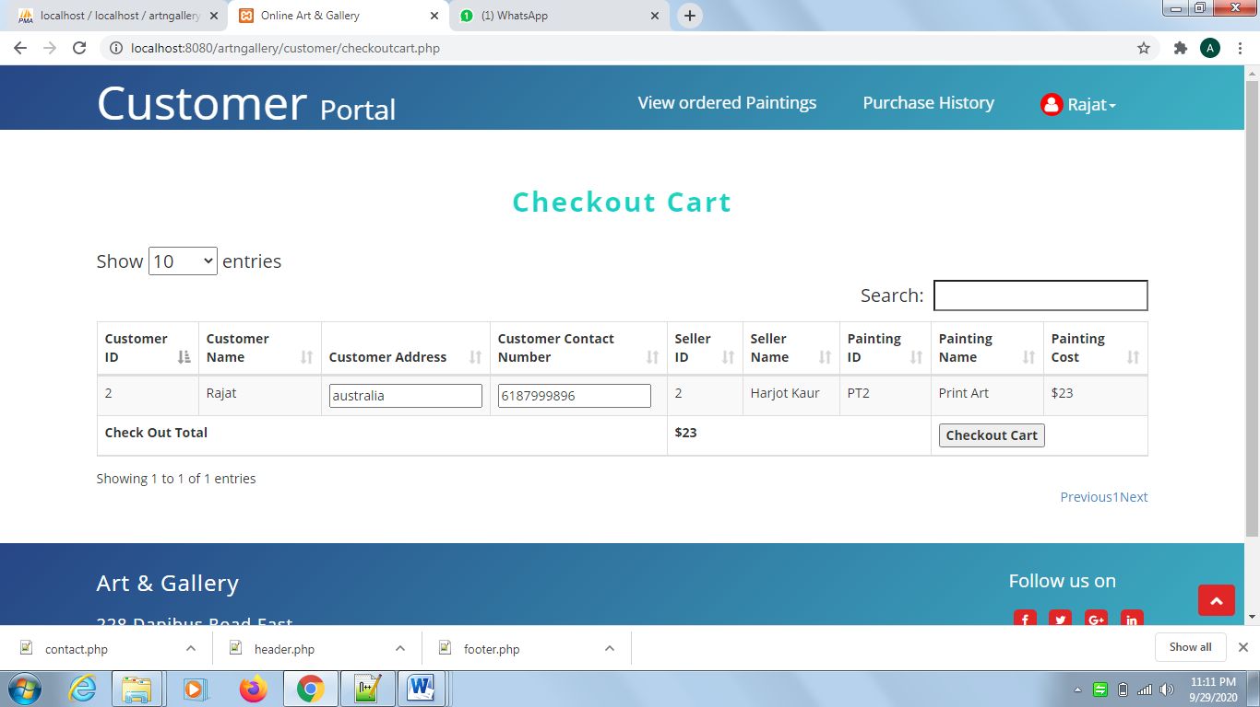After valid credentials, the painting details will be displayed in table format and customer needs to click on the checkout cart button for further processing.

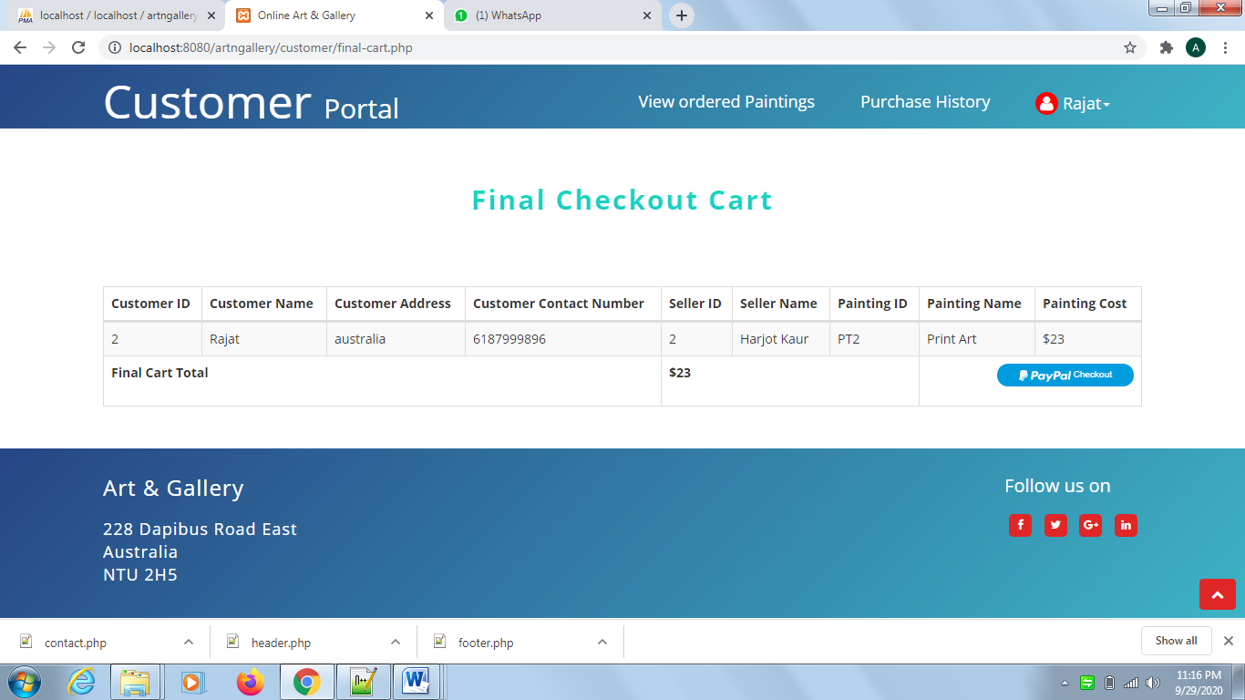  
**Figure 9: Final Checkout cart webpage:** The Paypal button will be display, customer will redirect to the paypal gateway for making payment using paypal by clicking on paypal button.

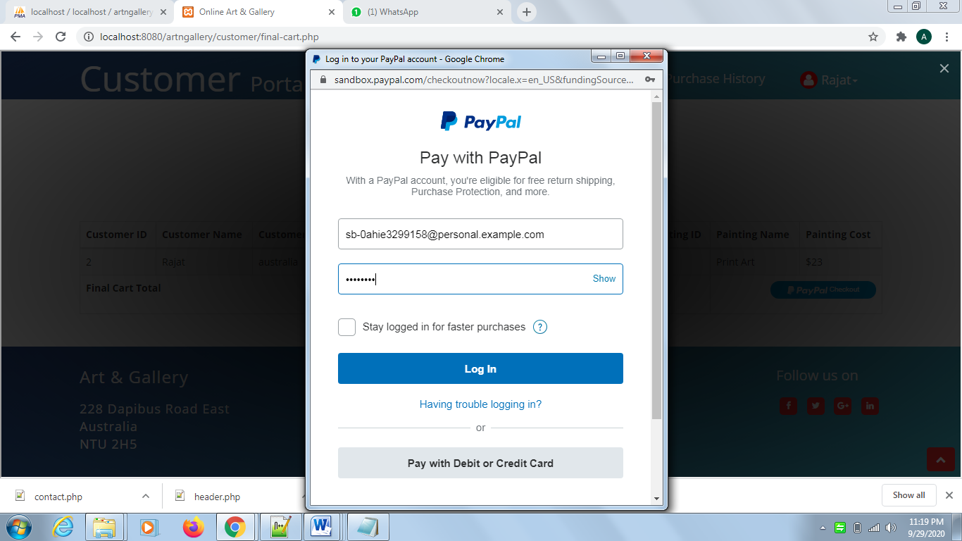

**Figure 10: Paypal Login Popup:** Customer needs to input the personal sandbox email id and password details for testing the payment process of developed web application.

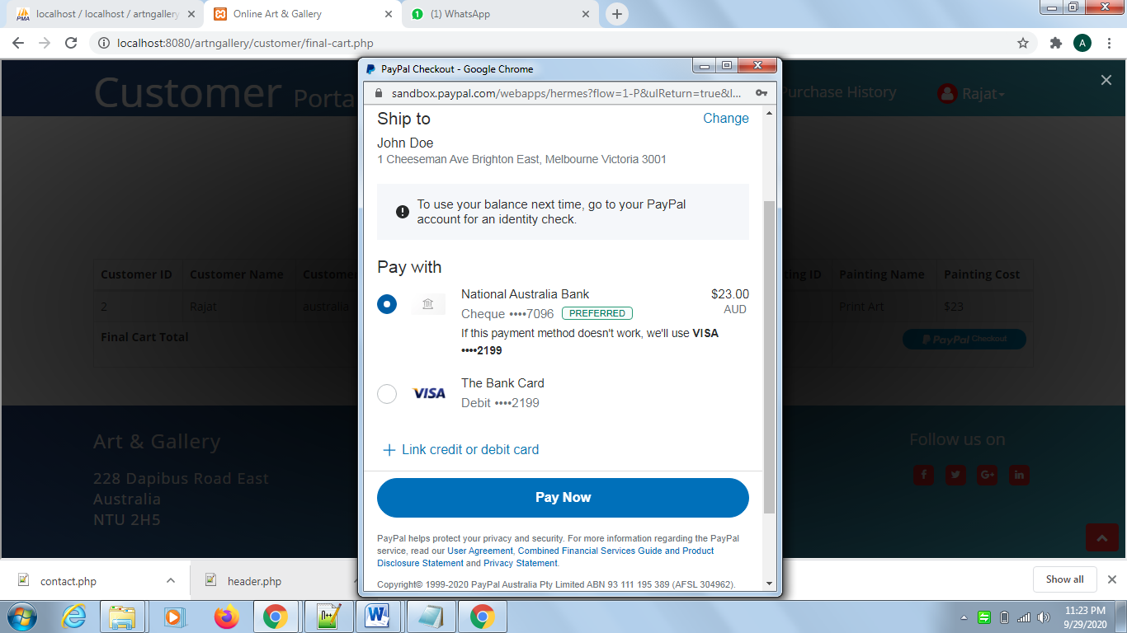

**Figure 11: Paypal Payment details:** Sandbox personal details are being used to test the payment process of application, customer can click on pay now button for making payment.

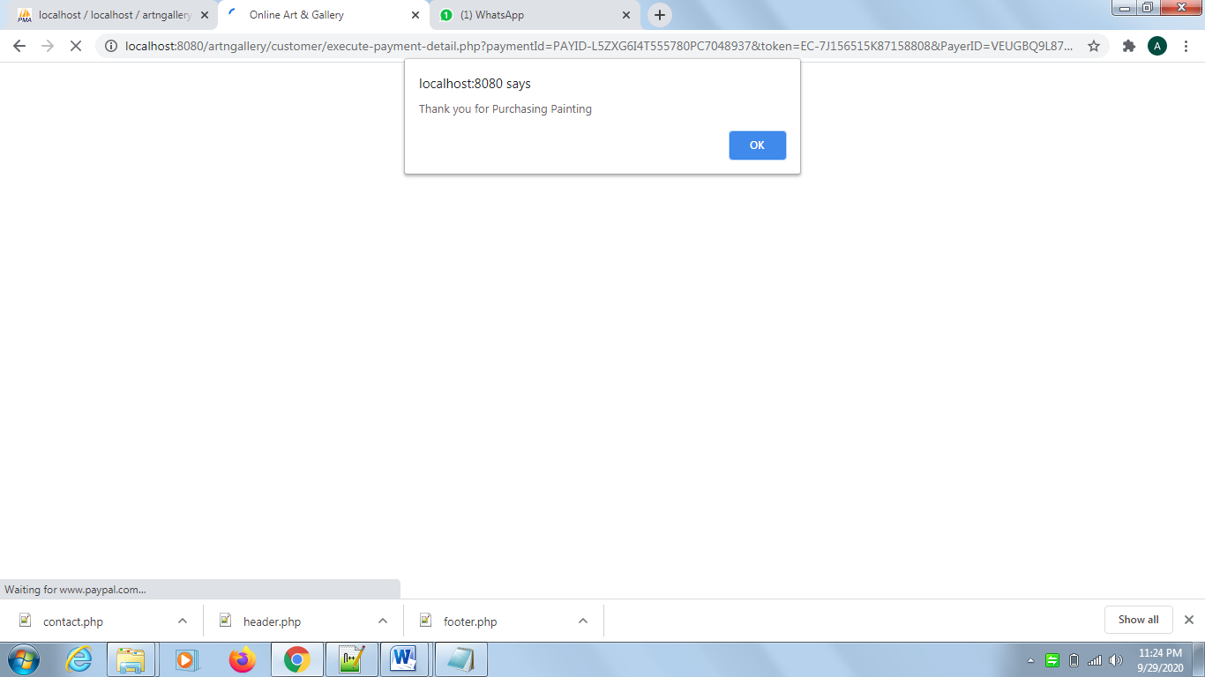 **Figure 12: Thank you Alert:** “Thank you for purchasing paintings” alert box will be shown after successful payment.

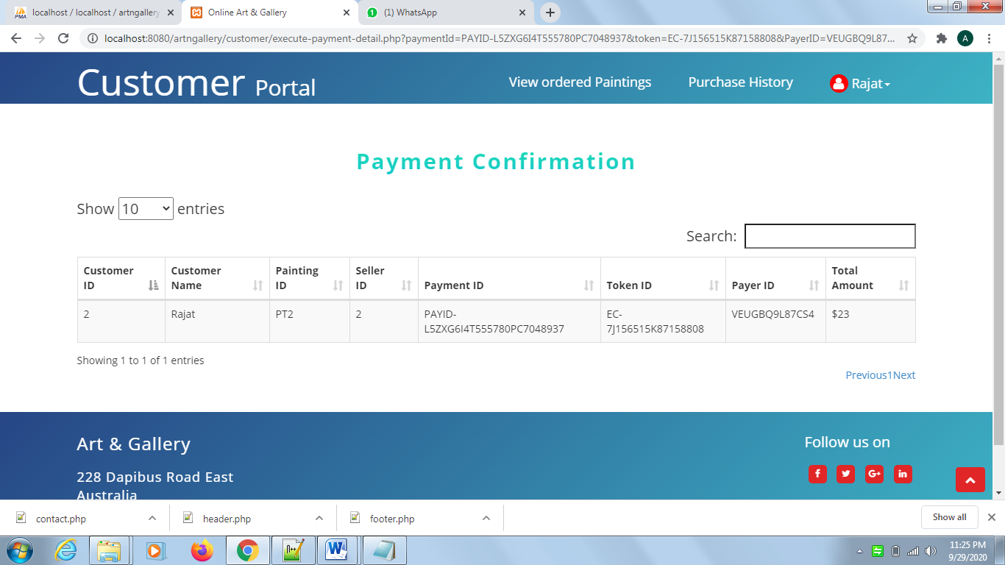

**Figure 13: Payment Confirmation webpage:** After completing paypal payment process, the payment id, token, and payer id details will be shown on this web page.

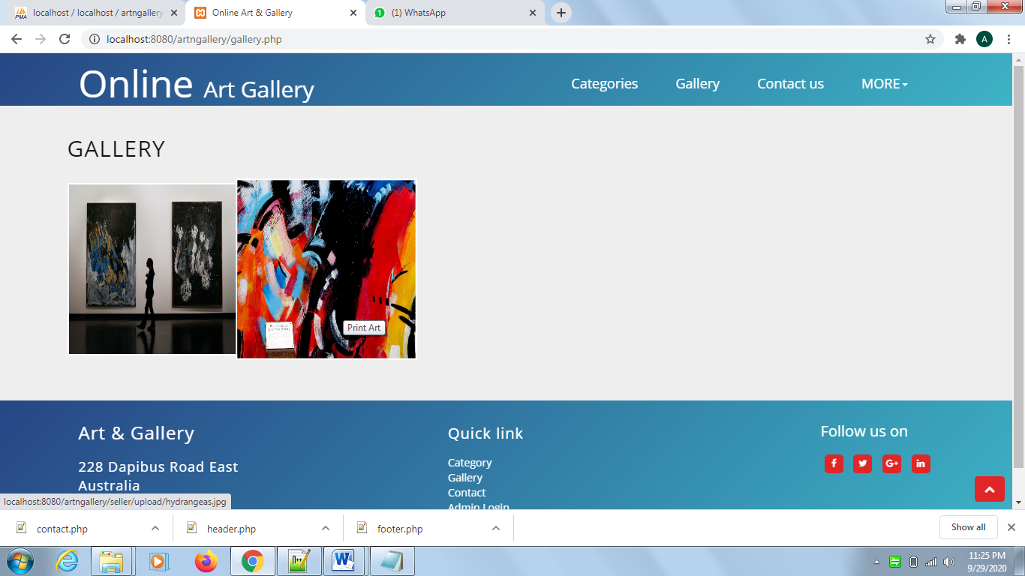

**Figure14: Gallery webpage:** All the uploaded paintings will be displayed on this web page.

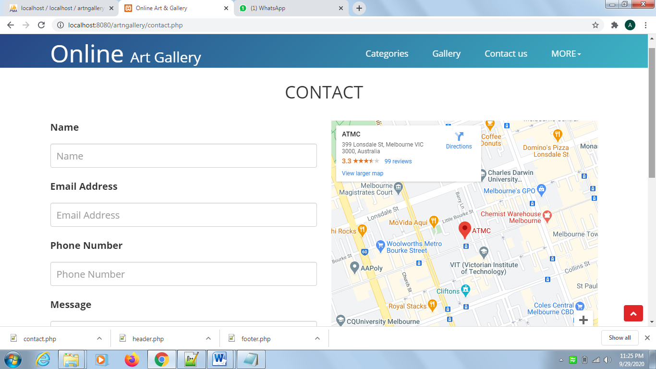

**Figure 15: Contact us webpage:** Visitors can see the contact details on this webpage.

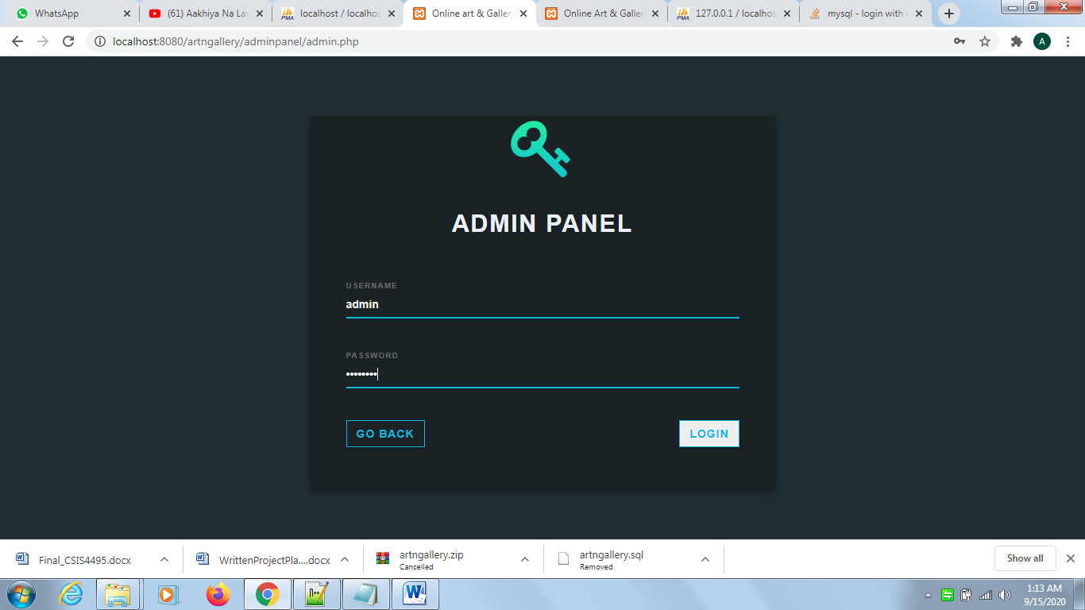

**Figure 16: Admin Login webpage:** Admin can login by inputting the valid credentials.

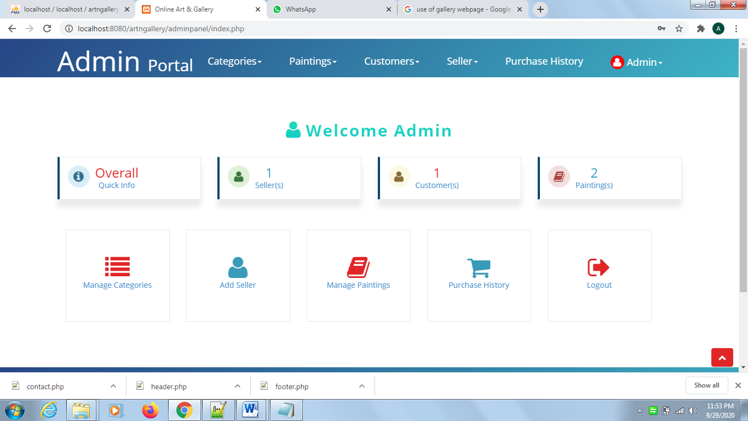

**Figure 17: Admin portal index webpage:** This is the index page of admin portal having menu bar, quick information and the quick links.

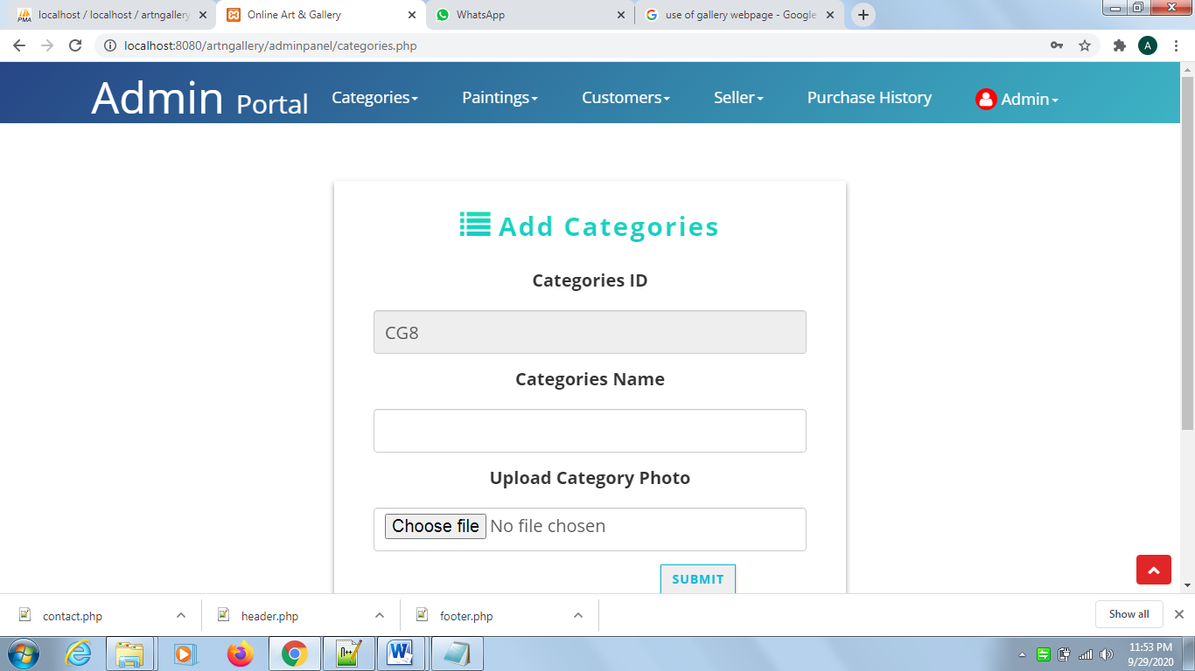

**Figure 18: Add Categories webpage:** Admin can add new categories using this web page which will be by default displayed on the categories web page.

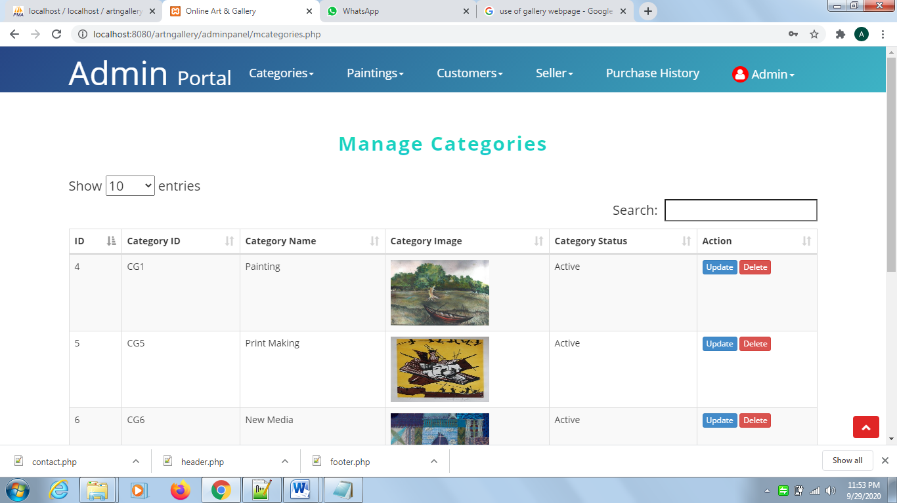

**Figure 19: Manage Categories webpage:** Categories can be managed using two action buttons i.e. Update and delete.

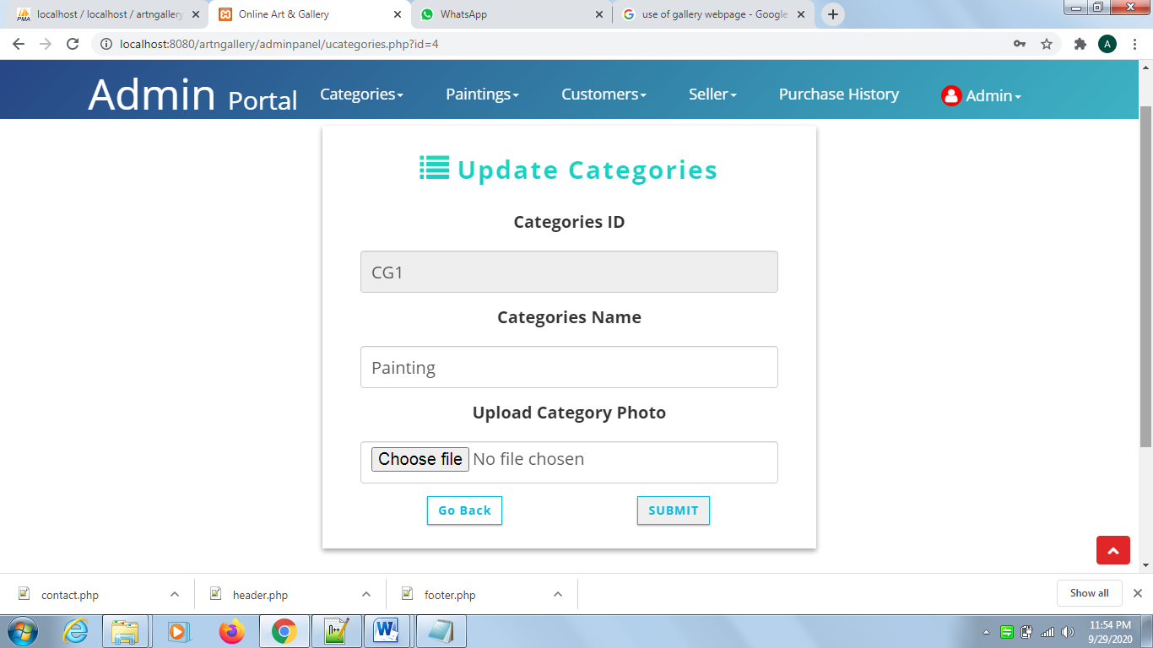

**Figure 20: Update Categories webpage:** Categories can be managed using two action buttons i.e. Update and delete

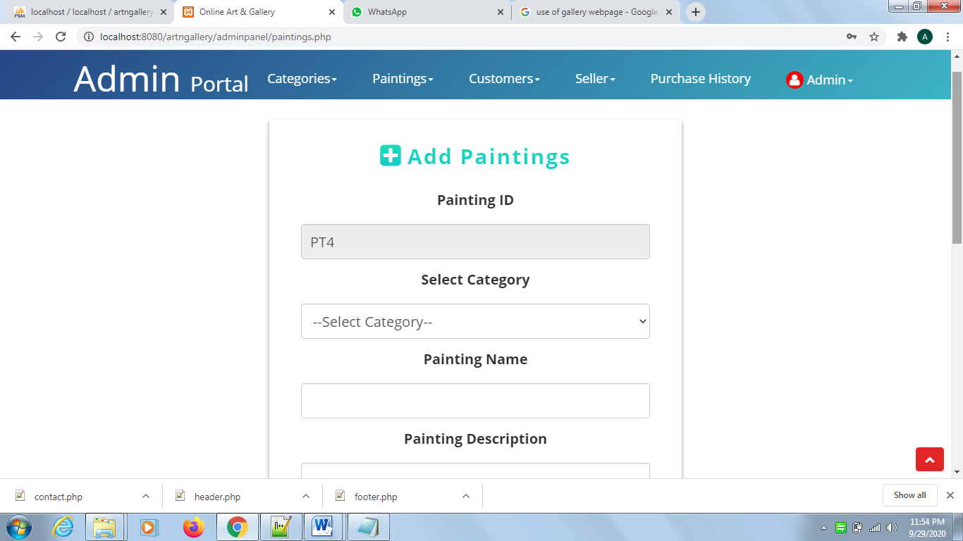

**Figure 21: Add Paintings webpage:** Admin can add painting by entering painting details and painting image.

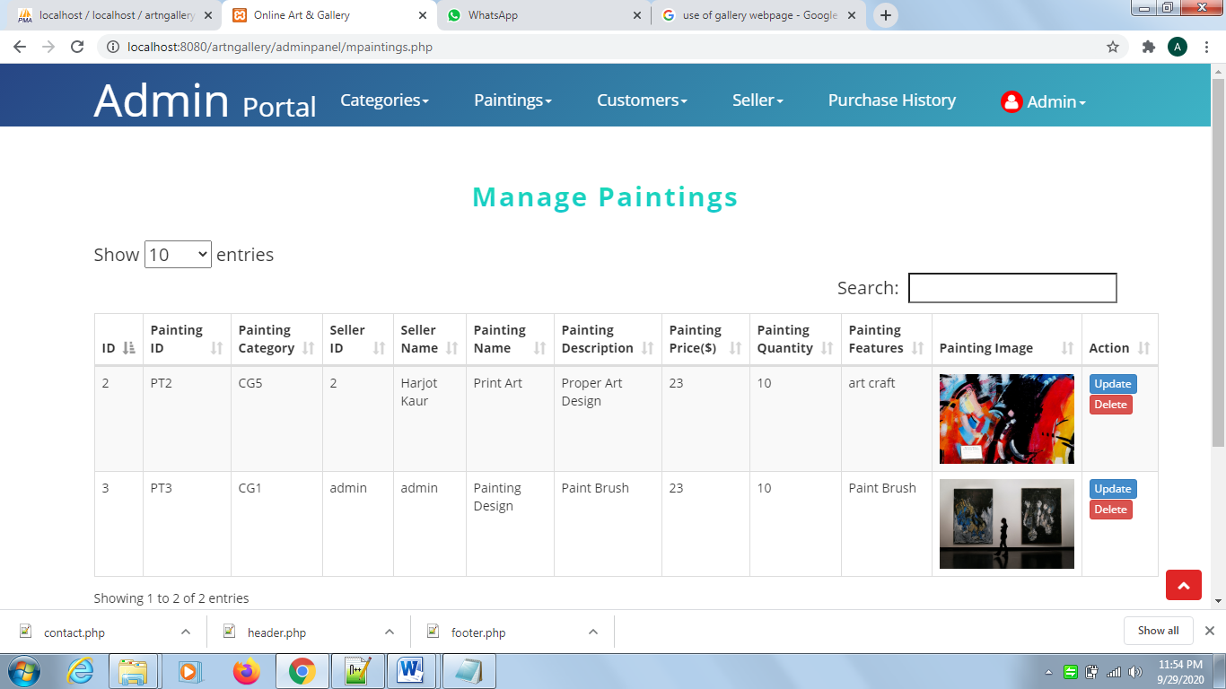

**Figure 22: Manage Paintings webpage:** Admin can manage paintings using this webpage. This webpage has two action buttons, Admin can update or delete the paintings using delete and update button.

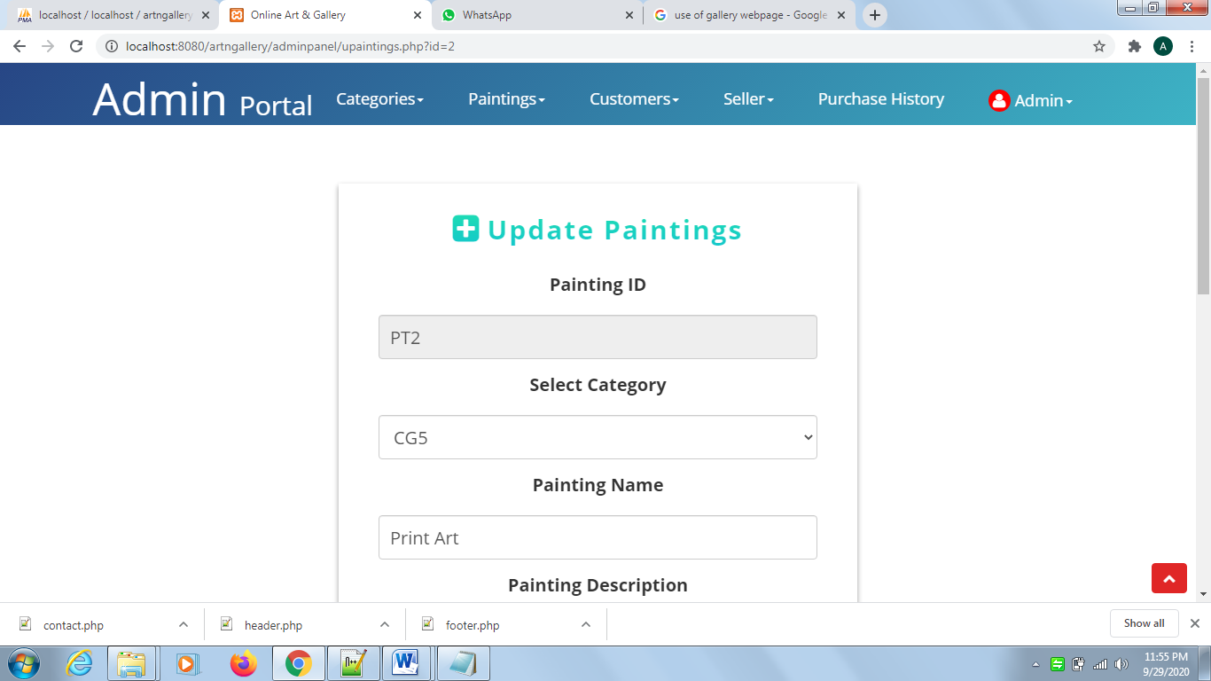

**Figure 23: Update Painting webpage:** This webpage will be shown when admin click on the update action button from the list of painting. Admin can update the painting details using this webpage.

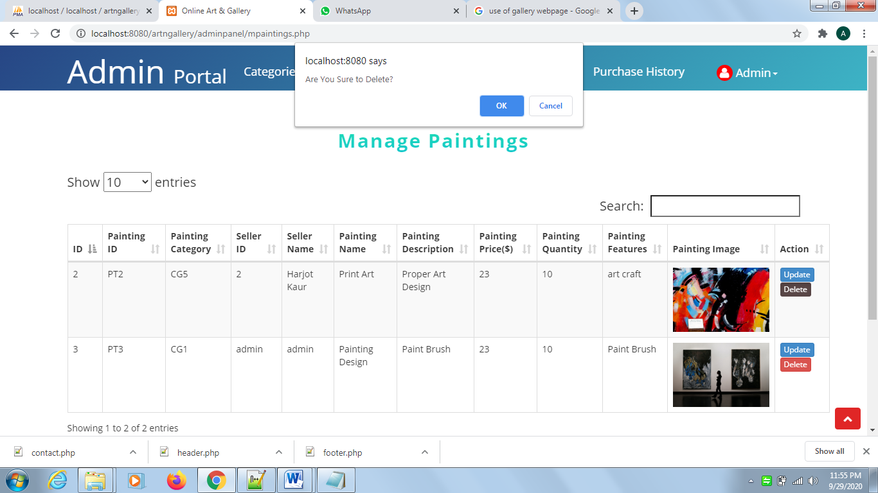

**Figure 24: Delete alert box:** delete alert will be appeared when admin clicks on the delete action admin. If admin clicks ok then delete action will be performed.

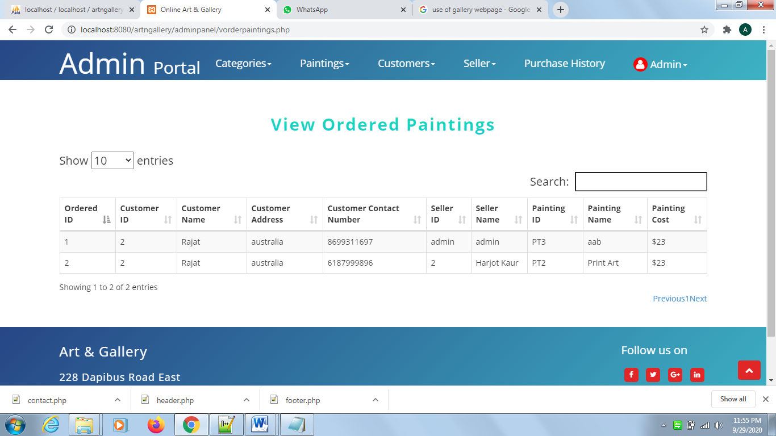

**Figure 25: View ordered paintings webpage:** This webpage is used to view all ordered paintings.

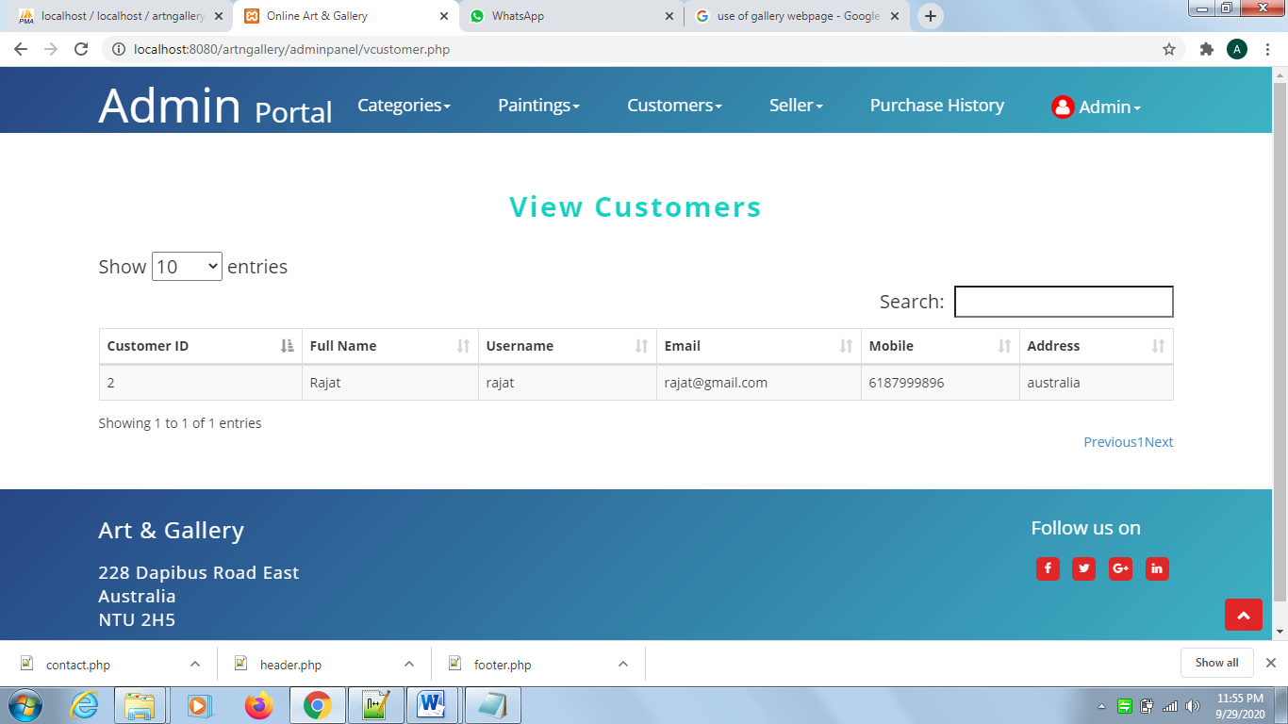

**Figure 26: view customers webpage:** This webpages is used to view the record of the customers.

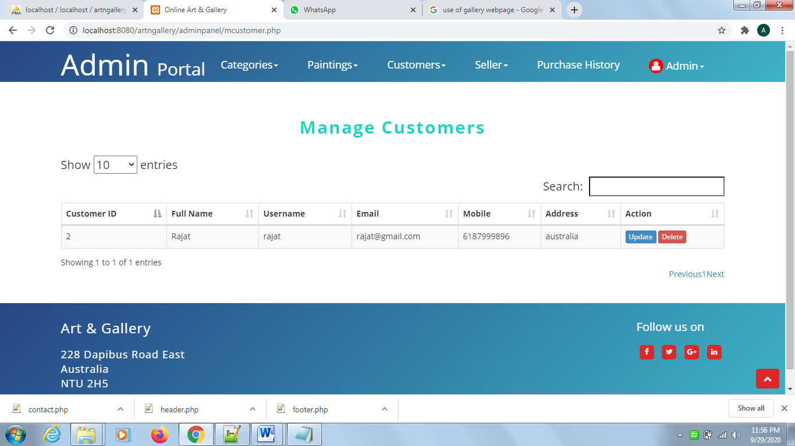

**Figure 27: manage customer webpage:** Categories can be managed using two action buttons i.e. Update and delete

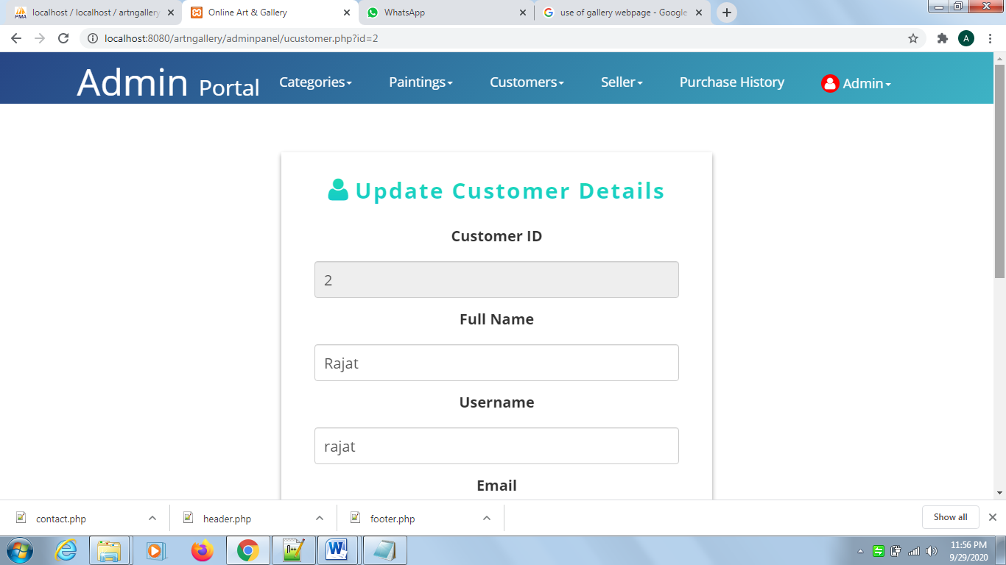

**Figure 28: Update Customer details webpage:** admin can update the details of customer using this webpage.

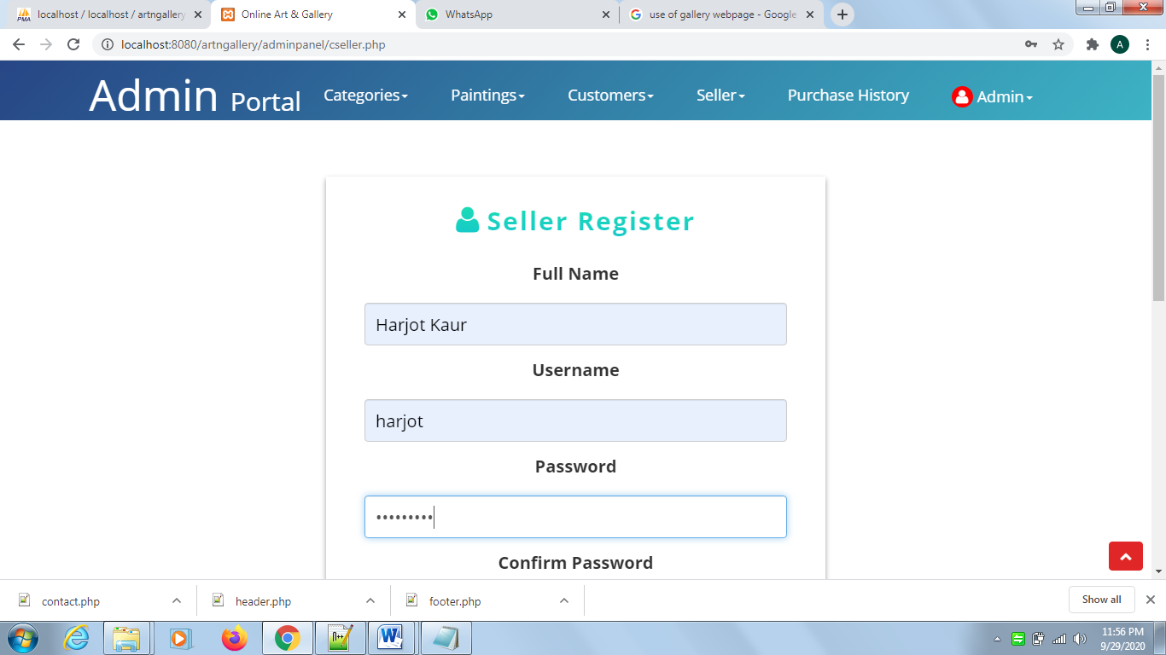

**Figure 29: Seller Register webpage:** Admin can add new seller by entering the seller details in this webpage.

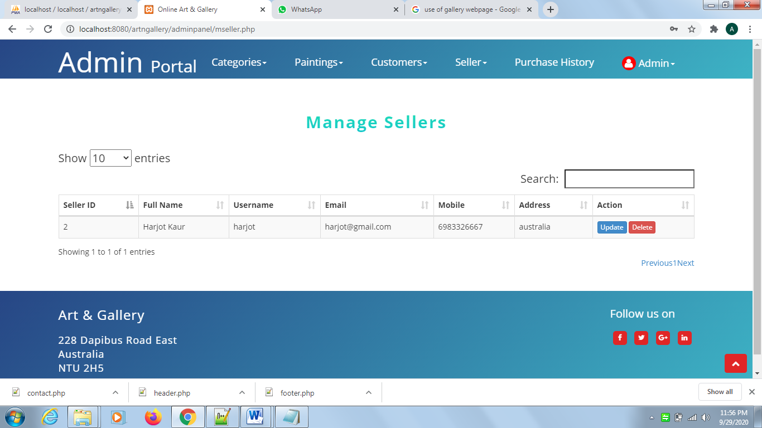

**Figure 30: Manage Sellers webpage:** Admin can manage the seller details using this webpage and can perform action by clicking on update or delete button.

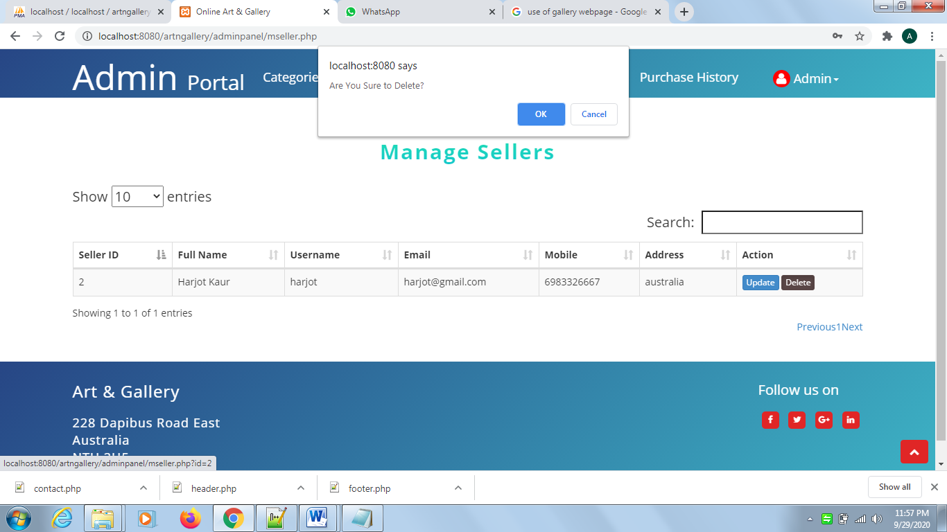

**Figure 31: Delete alert box:** delete alert will be appeared when admin clicks on the delete action admin. If admin clicks ok then particular seller details will be deleted.

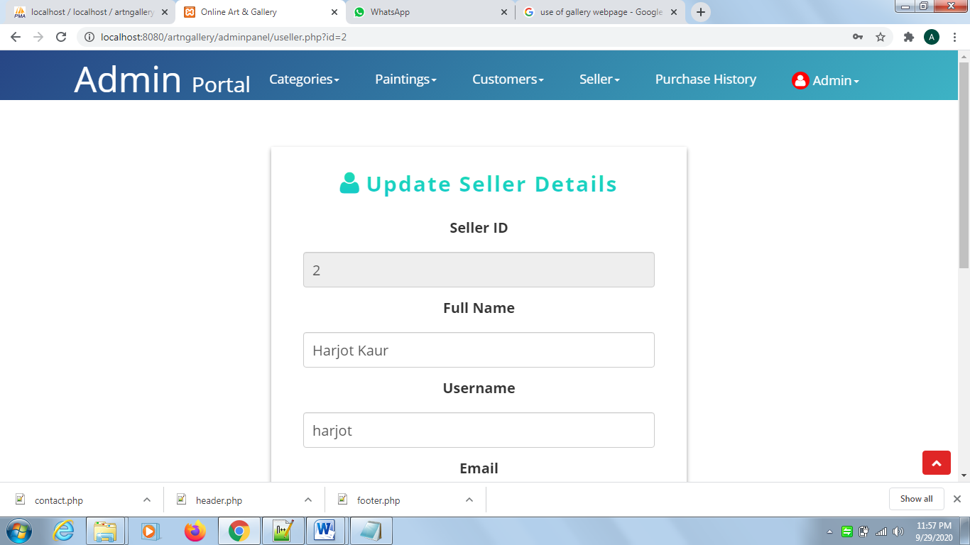

**Figure 32: Update Seller details webpage:** admin can update the details of seller using this webpage.

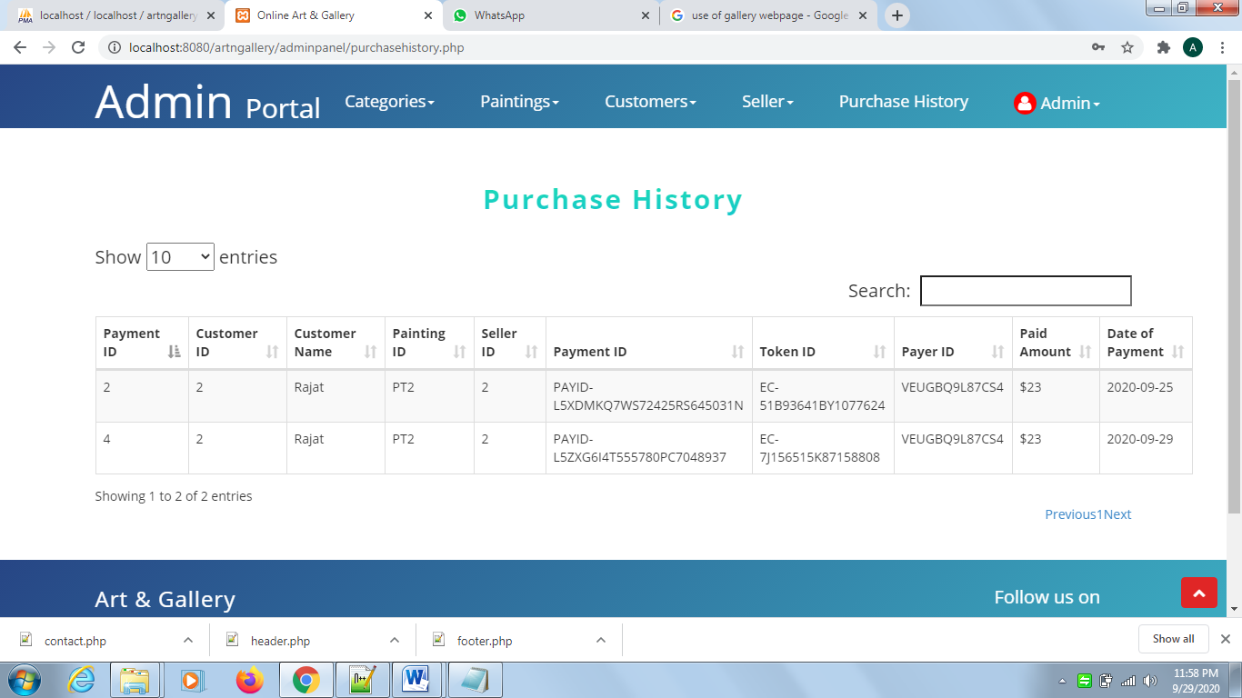

**Figure 33: Payment history webpage:** All the transactional history can be viewed on this webpage; this table contains information about receiving amount and its payment id.

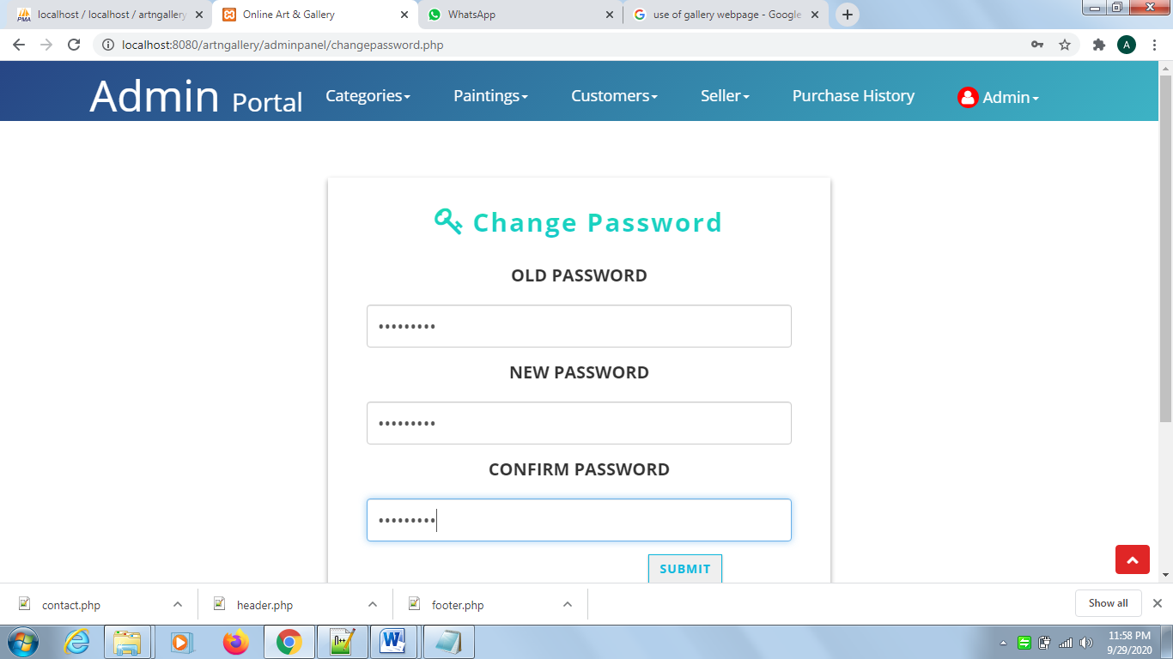

**Figure 34: Change password webpage:** Admin can change the password by entering the old password and new password.

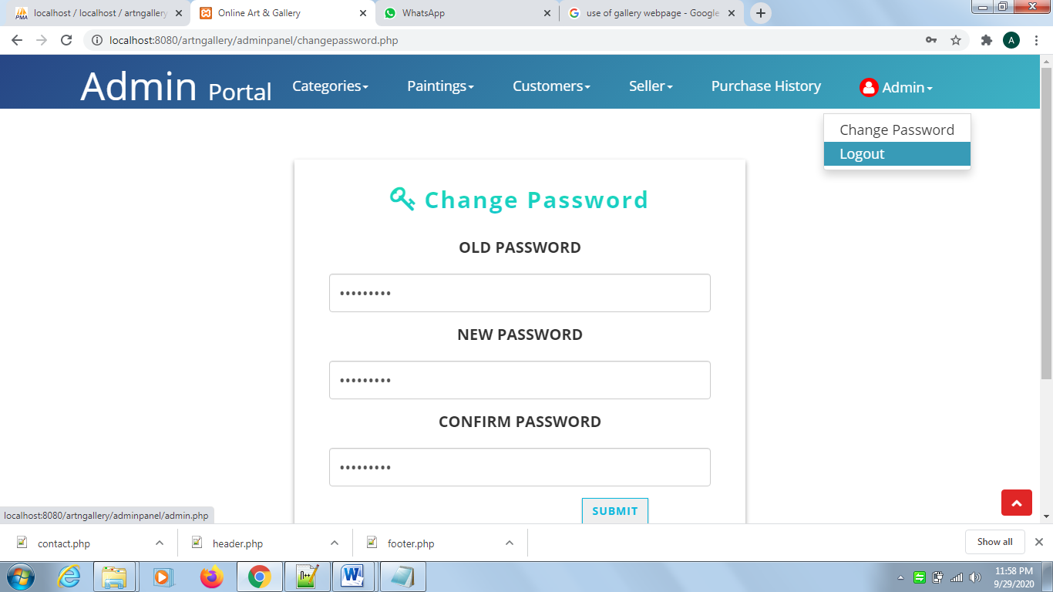

**Figure 35: Logout Option:** By clicking on logout option, the admin login web page will be appeared where the admin can directly go to the index webpage of online art gallery by clicking “Go Back” button.

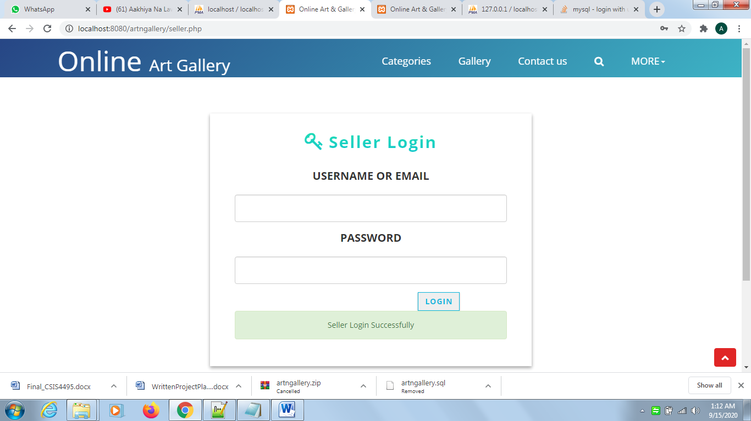

**Figure 36: Seller Login webpage:** Seller can login by inputting the valid credentials.

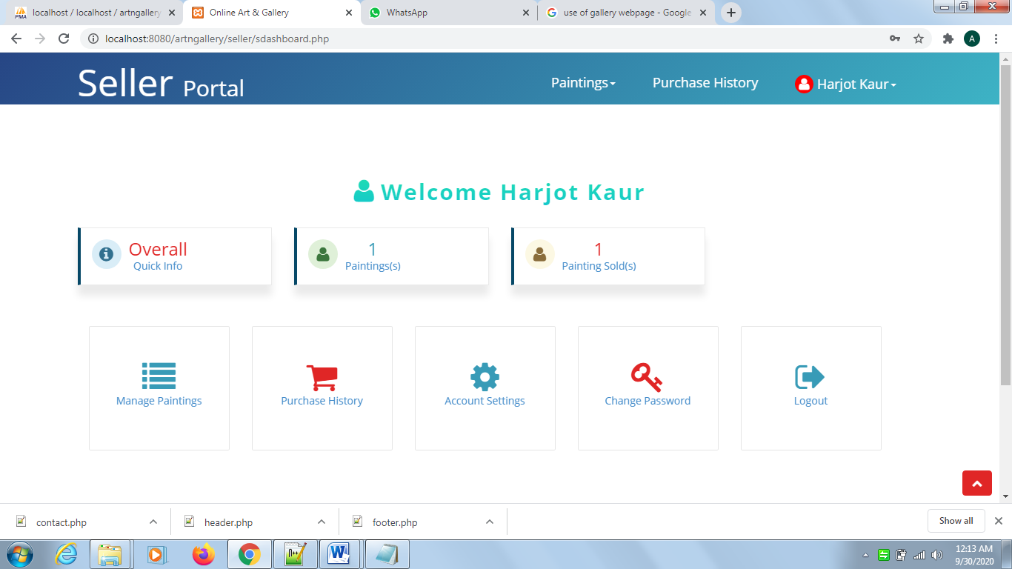

**Figure 37: Seller portal index webpage:** This is the index page of seller portal having menu bar, quick information and the quick links.

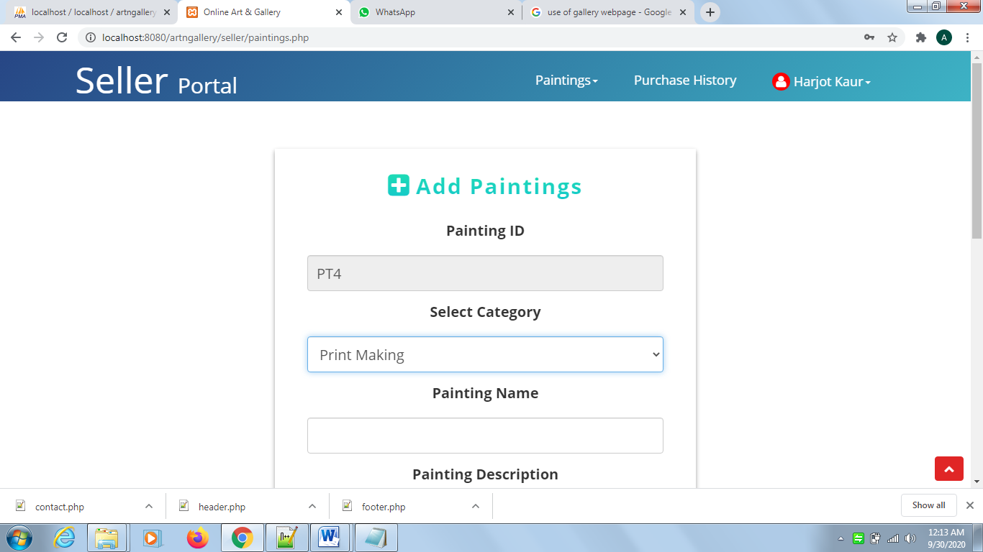

**Figure 38: Add Paintings webpage:** Seller can add painting by entering painting details and painting image.

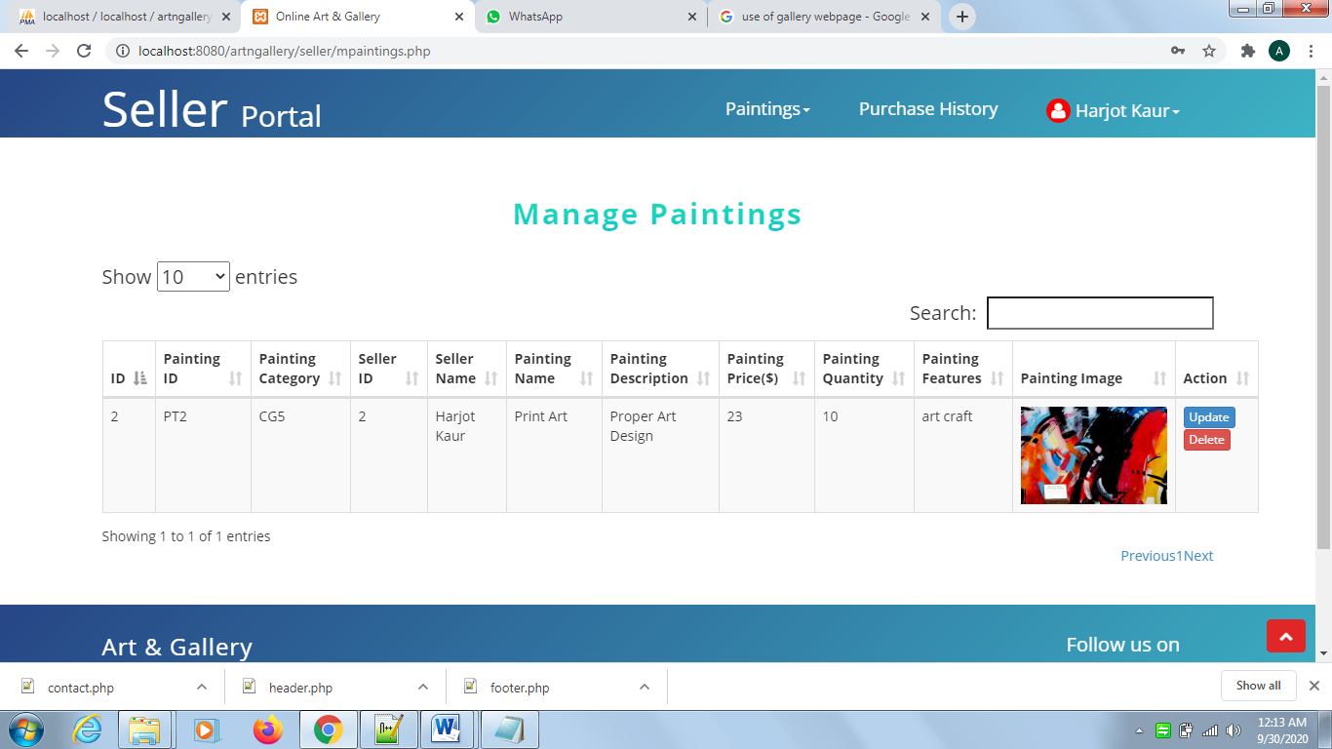

**Figure 39: Manage Paintings webpage:** Seller can manage paintings using this webpage. This webpage has two action buttons, Seller can update or delete the paintings using delete and update button.

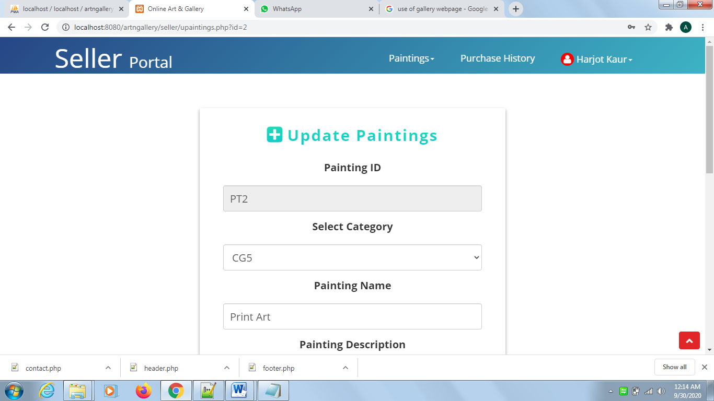

**Figure 40: Update Painting webpage:** This webpage will be shown when seller clicks on the update action button from the list of painting. Seller can update the painting details using this webpage.

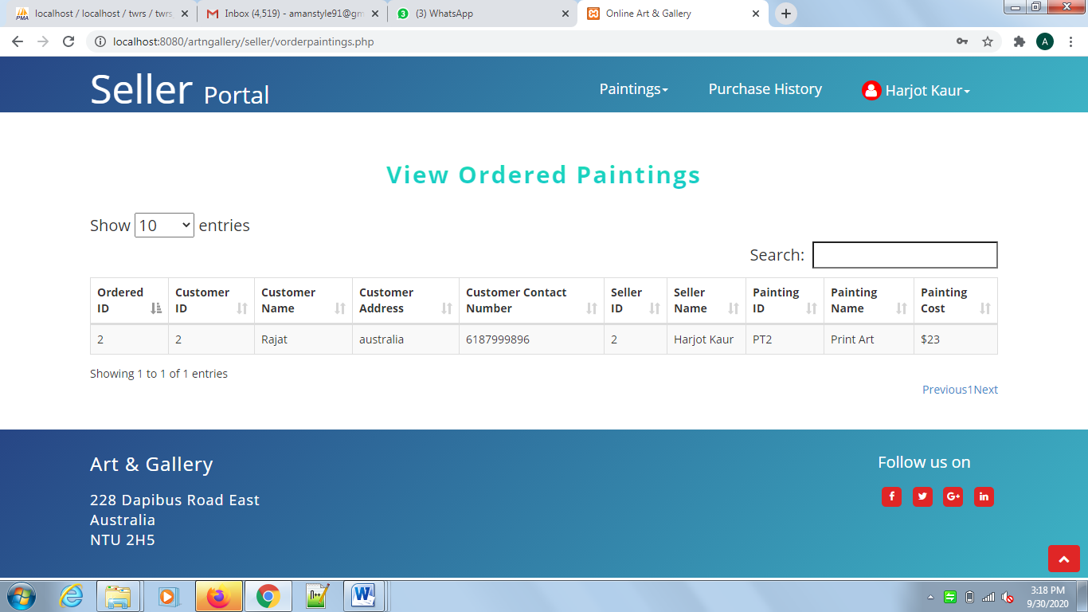

**Figure 41: View ordered paintings webpage:** This webpage is used to view all ordered paintings.

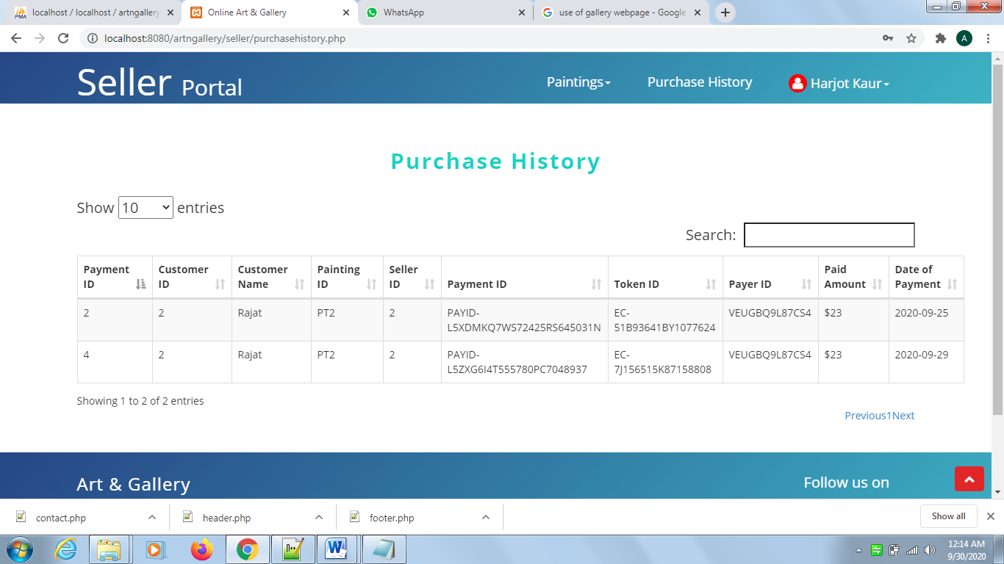

**Figure 42: Purchase history webpage:** Seller’s receiving money and transactional history can be viewed on this webpage.

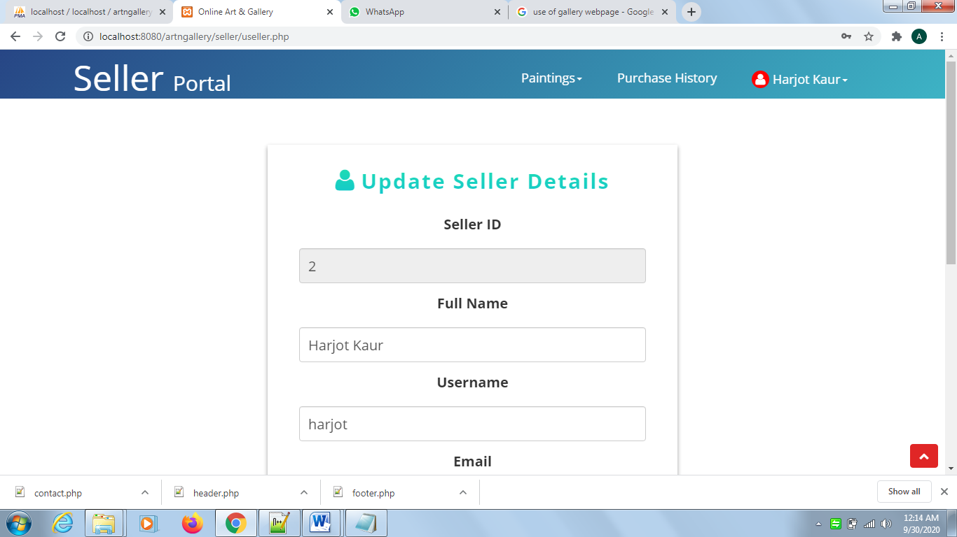

**Figure 43: Update Seller details webpage:** Seller can update the details using this webpage.

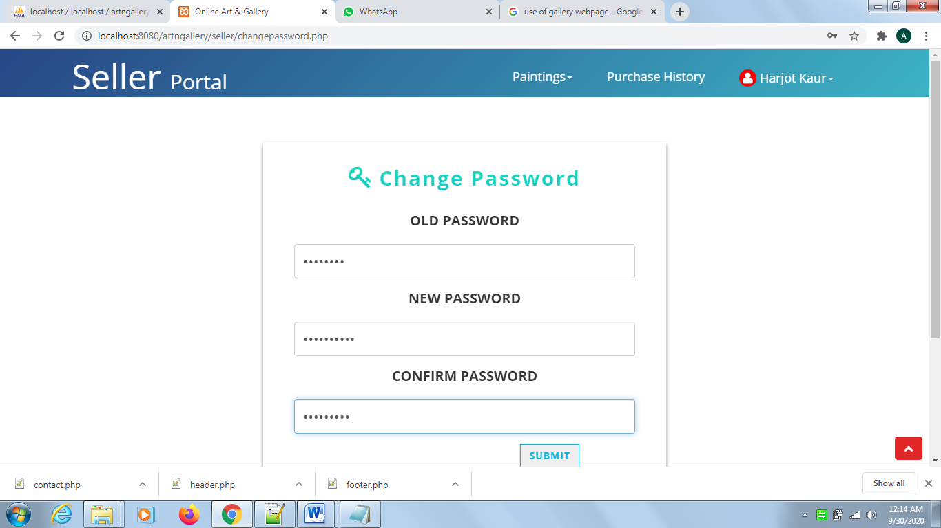

**Figure 44: Change password webpage:** Seller can change the password by entering the old password and new password.

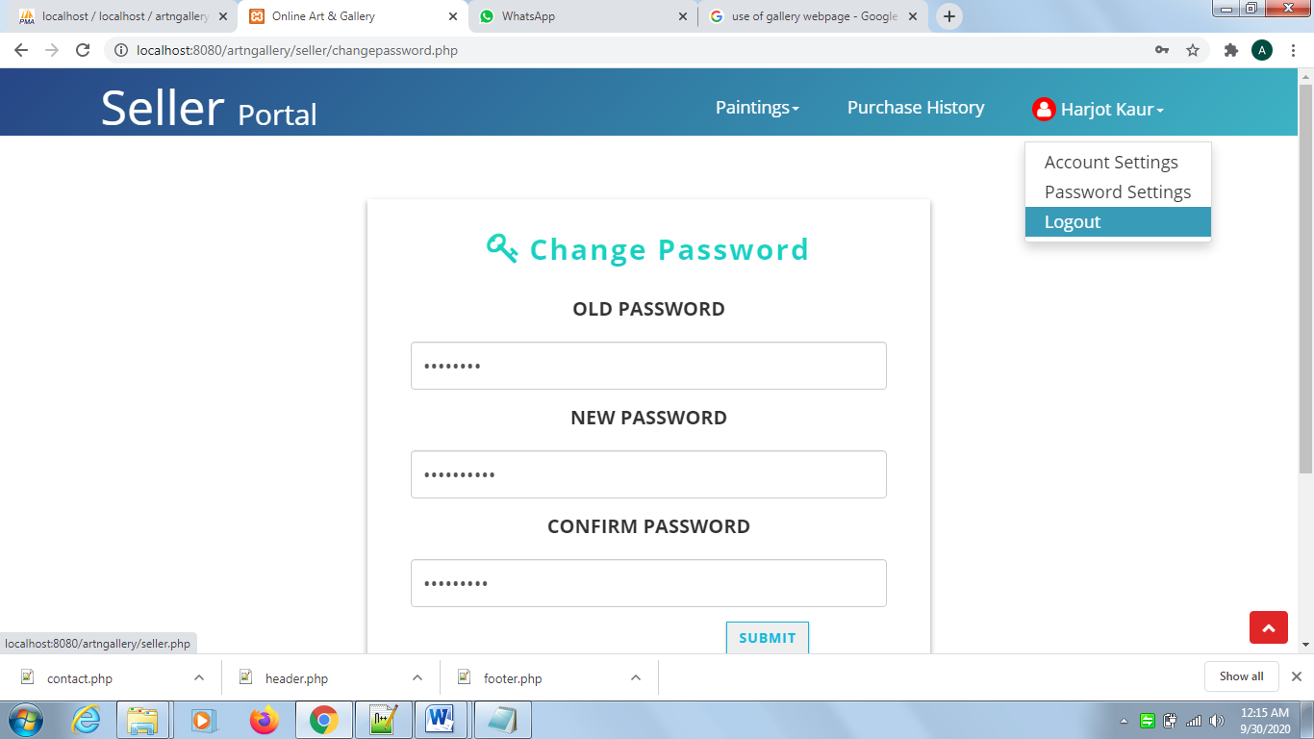

**Figure 45: Seller Logout Option:** Sellers can logout from seller portal using this option.

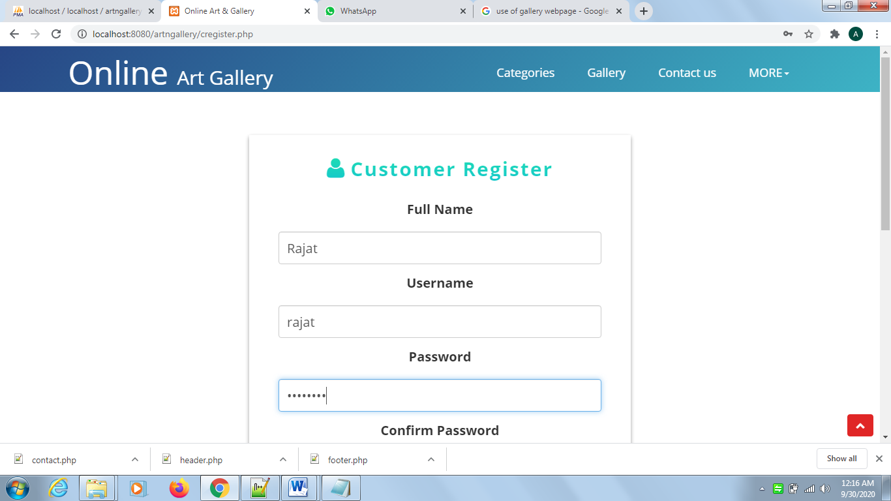

**Figure 46: Customer Register webpage:** New customer can access customer portal by registering himself using this webpage.

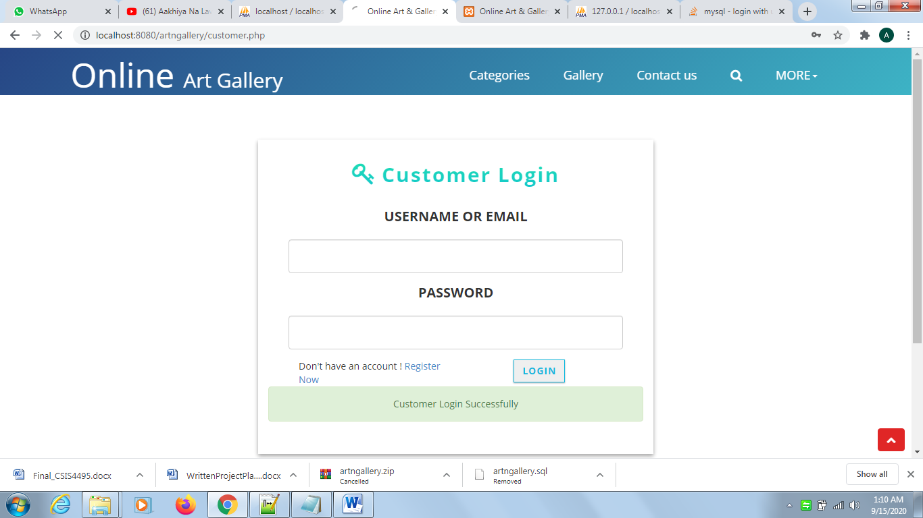

**Figure 47: Customer Login webpage:** Customer can login by inputting the valid credentials.

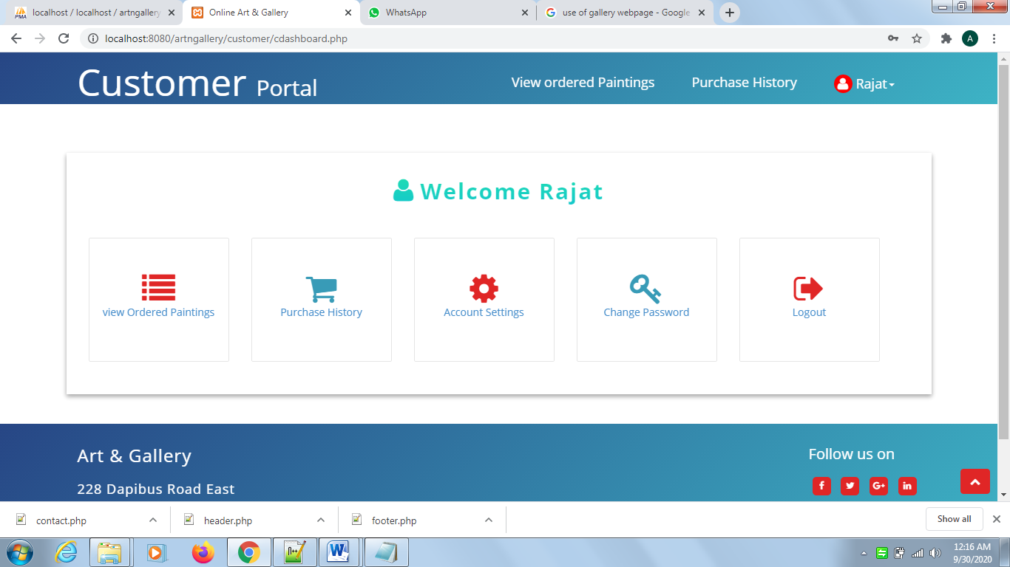

**Figure 48: Customer portal index webpage:** This is the index page of customer portal having menu bar and the quick links.

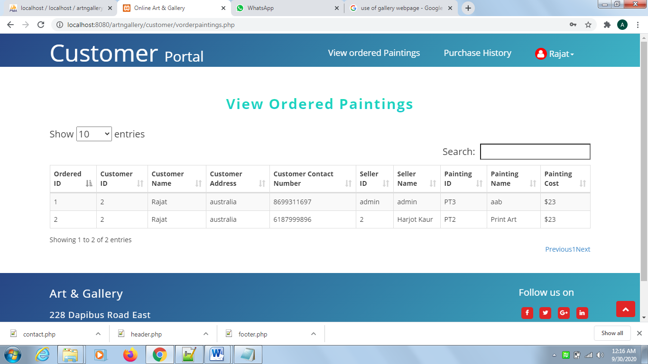

**Figure 49: View ordered paintings webpage:** This webpage is used to view all ordered paintings.

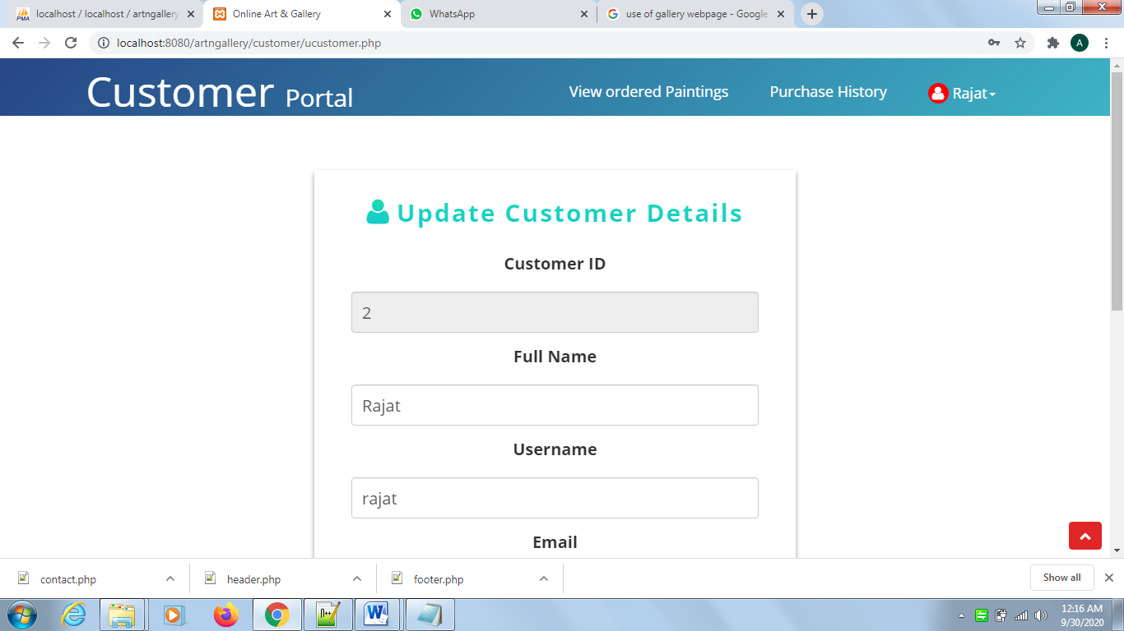

**Figure 50: Update Customer details webpage:** Customer can update the details using this webpage.

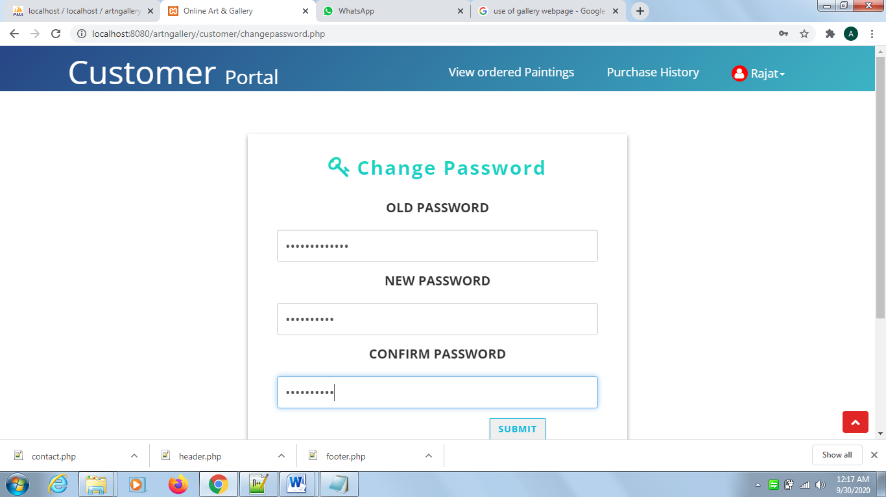

**Figure 51: Change password webpage:** Customer can change the password by entering the old password and new password.

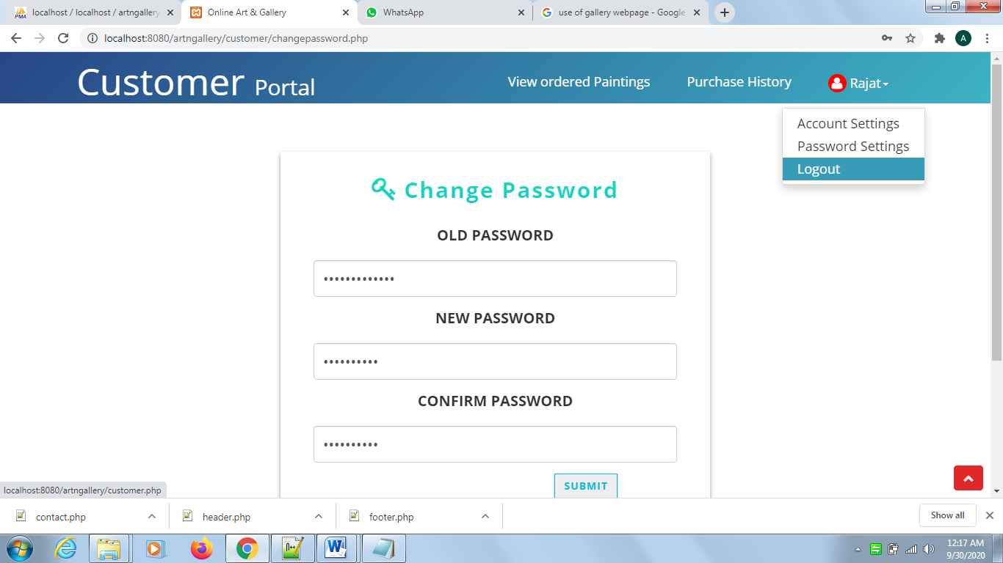

**Figure 52: Seller Logout Option:** Sellers can logout from seller portal using this option.

**Coding Principles**

We have used solid principle which makes it easy for a programmer to develop web applications that are easy to maintain and extend. These principles help developer to easily refactor code, and are also a part of the adaptive software development.

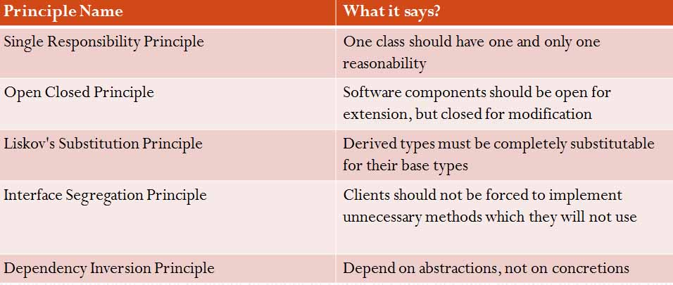

**Coding Screenshots**

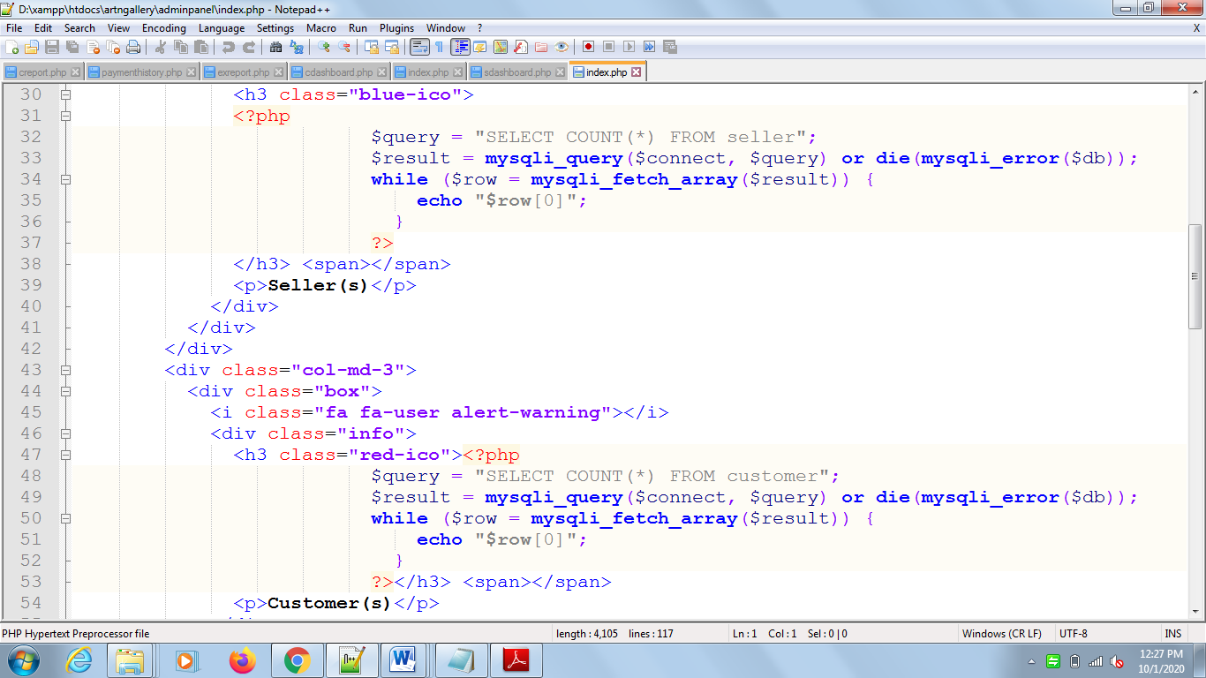

Admin Panel Index page Code Script

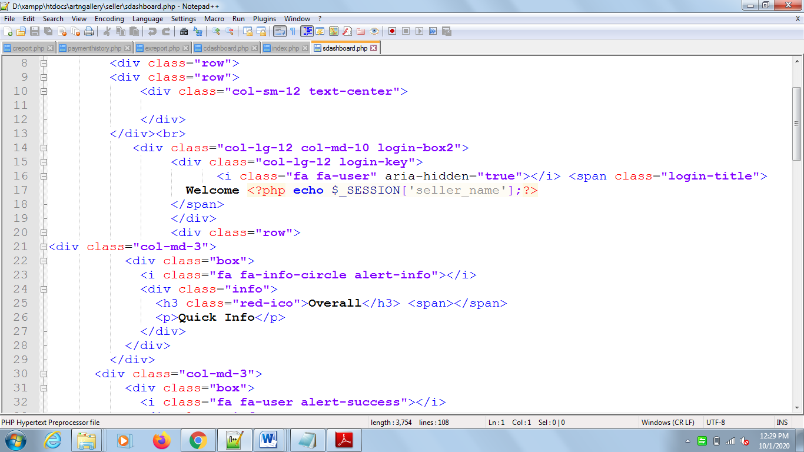

Seller Portal Index page Code Script

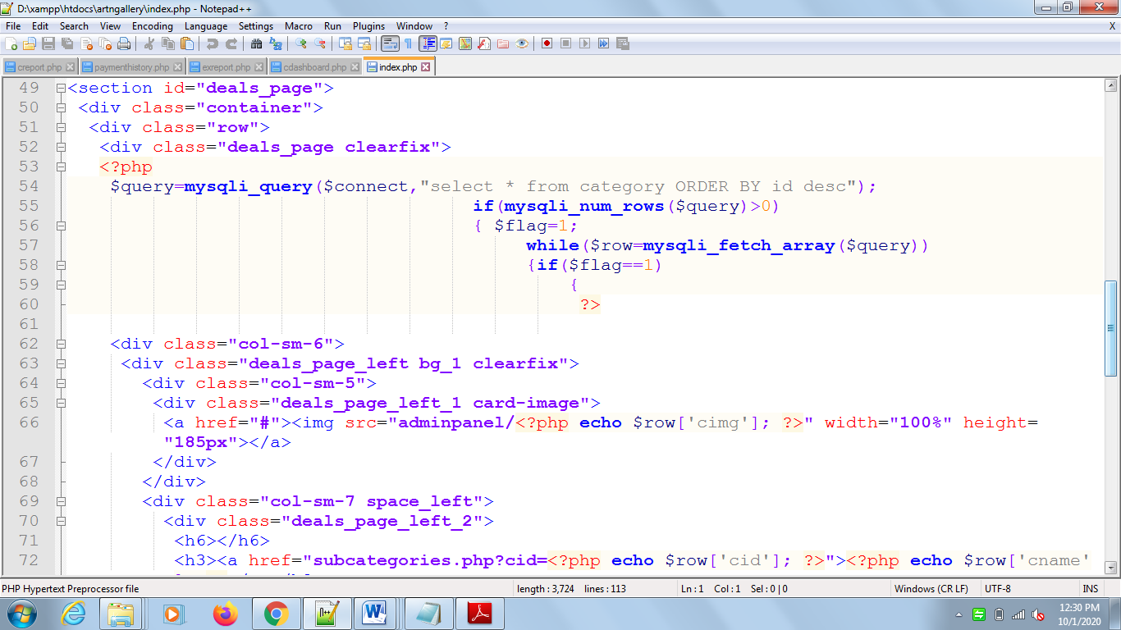

Index page Categories display Code Script

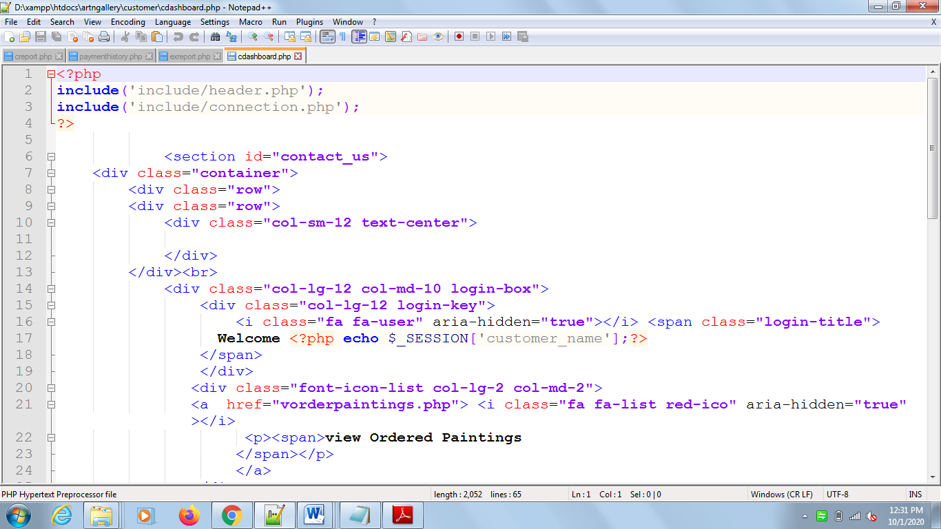

Customer Portal Index page Categories display Code Script

**Quality Control Plan**

**Quality Assurance**

Testing strategies need to be applied to maintain the quality of the delivered project. Following Testing strategies will be applied on art gallery web application.

# Testing Plans

We have used selenium for the testing and we have created the test cases for testing our web application using selenium.

**Admin Test Case**

This test case is for admin Portal of art gallery web application. Green lines indicated that the test case is being executed successfully and red lines indicate that test case is failed to input testing samples.

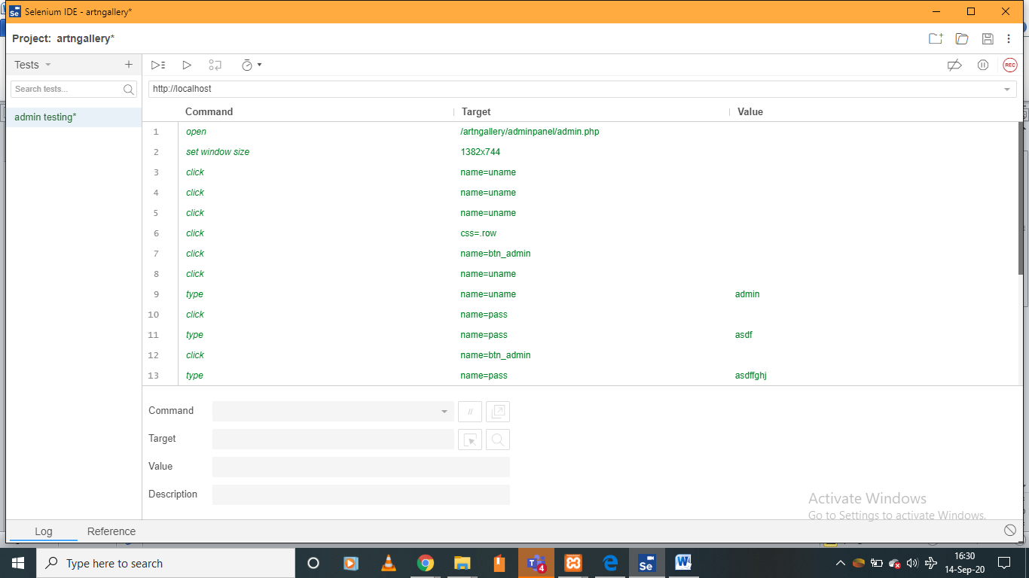

**Seller Test Case**

This test case is for seller Portal of art gallery web application. Green lines indicated that the test case is being executed successfully and red lines indicate that test case is failed to input testing samples.

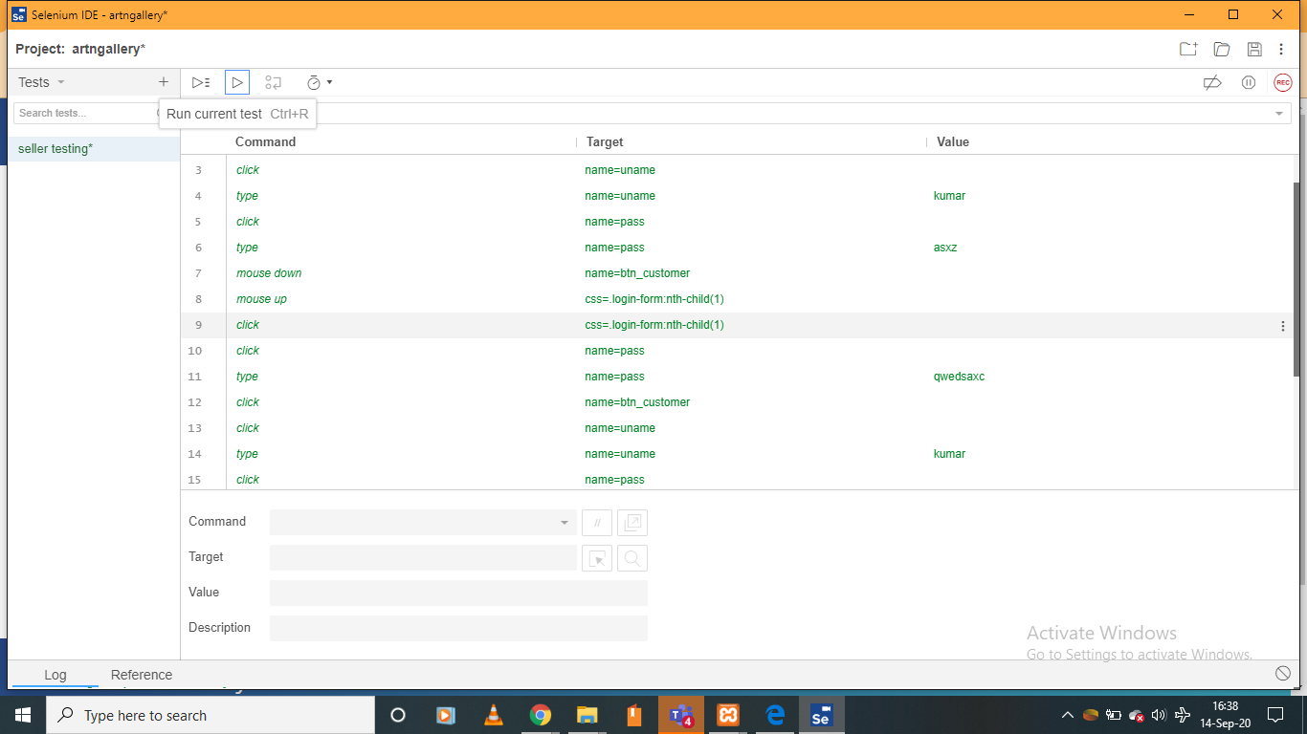

**Customer Test Case**

This test case is for customer Portal of art gallery web application. Green lines indicated that the test case is being executed successfully and red lines indicate that test case is failed to input testing samples.

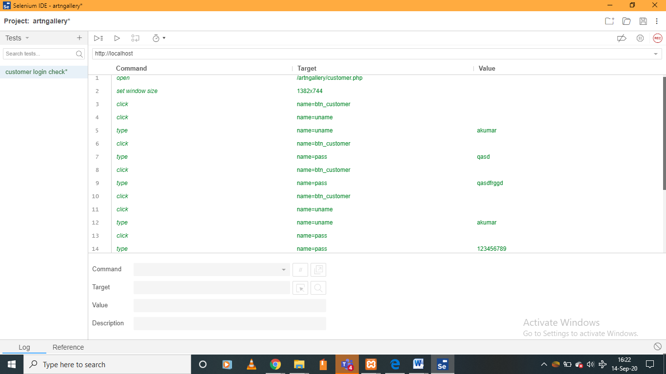

# Risk Management

Risk management is essentially a process in which threats are identified and controlled. (Carvalho, 2015) The plan of risk management for our online art gallery web application is required to estimate the impacts arose in the real-time.

|  |  |  |  |  |
| --- | --- | --- | --- | --- |
| **Risk ID** | **Risk** | **Impact** | **Risk Response** | **Contingency Plan** |
| ARG01 | Data misplace or not found | Medium | Accept | It is essential to take backup to manage or recover the data. |
| ARG02 | Requirements not fulfil | high | Transfer | Did proper research on finding the proper solution of given problem. |
| ARG03 | Unauthorised use | high | Accept | We have used proper jquery validation on the web pages to validate the data like  $("#customer-form").validate({  rules: {  uname: "required",  pass: {  required: true,  minlength: 8  }    },  messages: {  uname: "Please enter Username",  pass: {  required: "Please provide a password",  minlength: "Your password must be at least 8 characters long"  }  }, |
| ARG04 | Data Failure | Medium | Accept | Proper error message or warnings will be displayed to resolve the issues. |

1. **User Guide**

In Online art gallery application, we have three stakeholders’ seller, customers and admin. This user guide provides information to the user for running web application effectively.

**Admin**

Admin can manage customers, sellers and can add or update the categories, Painting details. Also, ordered history and payment record can be viewed from admin portal. The available options are:



**Seller Portal**

Seller can manage paintings, view ordered paintings and its transaction history. The options for Seller are:



**Customer Portal**

Customer can view the ordered Paintings and transaction history using menu options.



**Deployment Guide**

Deployment guide provides a steps and installation requirements to run online art gallery web application. These steps are

1. Download the XAMPP server.
2. Install it any of the computer drive.
3. Start Apache and MySQL Service by using xampp control panel.
4. Go to drive where you have installed xampp server and open XAMPP folder
5. Open htdocs folder and extract the shared folder files from the github.
6. Open browser and import database file in PHPMYADMIN.
7. Write localhost/artngallery/
8. Index webpage will be appeared as followed:



# Deliverable

We have uploaded the web application code, user guide and deployment detail on the GitHub account. The GitHub Account details are

Github Username: ArtnGallery

Github Email ID: ict709artngallery@gmail.com

Password: S22020_127ict

**Conclusion**

The project has been completed and we all team members have learned new technical things with this delivered project.

**Client Approval**

We have got an approval from our client. Client has appreciated our efforts.

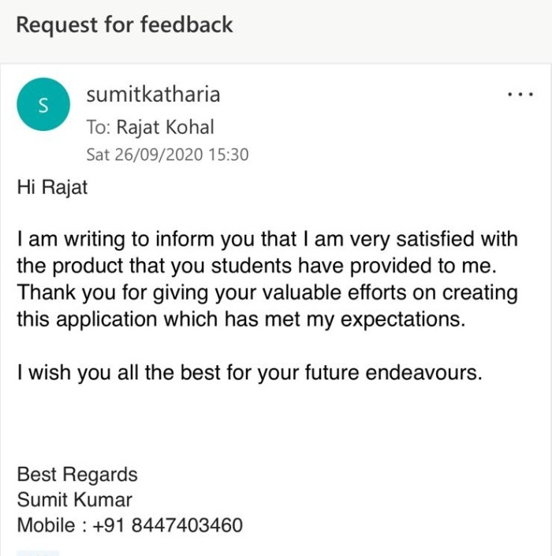

**References**

Russo, N.L. and Graham, B.R., 1999. A first step in developing a Web application design methodology: understanding the environment. In *Methodologies for Developing and Managing Emerging Technology Based Information Systems* (pp. 24-33). Springer, London.

Petersen, K., Wohlin, C. and Baca, D., 2009, June. The waterfall model in large-scale development. In *International Conference on Product-Focused Software Process Improvement* (pp. 386-400). Springer, Berlin, Heidelberg.

Carvalho, M.M.D. and Rabechini Junior, R., 2015. Impact of risk management on project performance: the importance of soft skills. *International Journal of Production Research*, *53*(2), pp.321-340.

Cinis, H. 2017, *Improving the Definition of Software Development Projects Through Design Thinking Led Collaboration Workshops*, The Institute of Electrical and Electronics Engineers, Inc. (IEEE), Piscataway.

Chao, B., Zhu, X., Li, Q. and Huang, A., 2006, June. Reliability management in software requirement analysis. In 2006 IEEE International Conference on Management of Innovation and Technology (Vol. 2, pp. 1104-1107). IEEE.

**Appendix**

**Client Meeting Minutes -1**

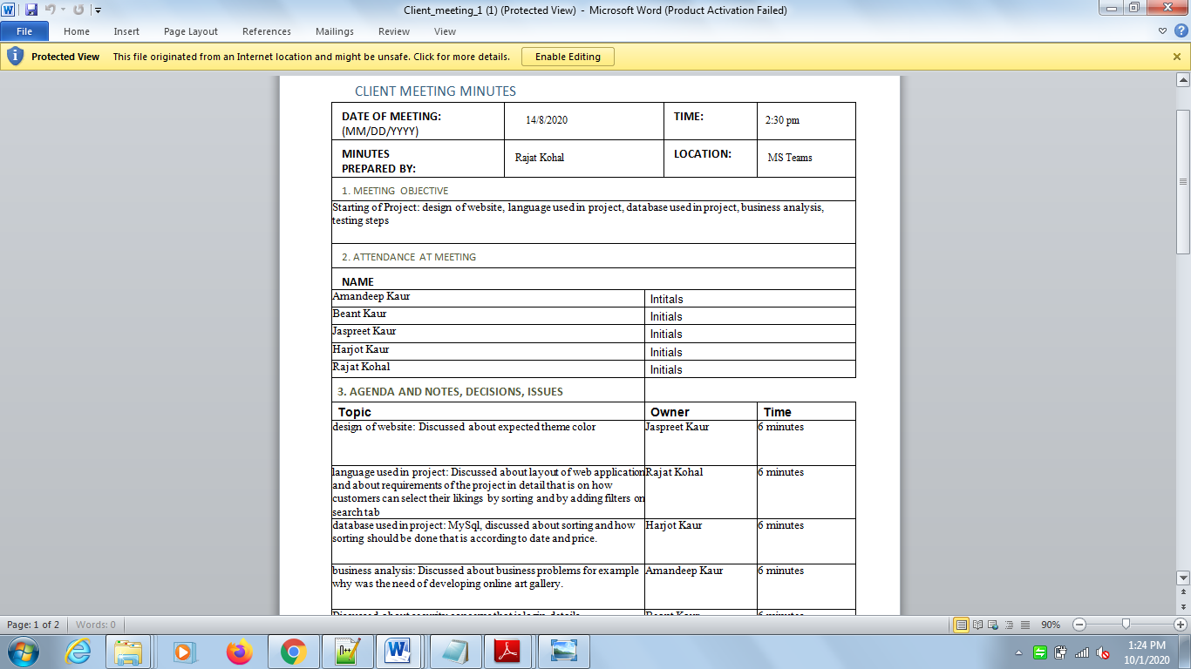

**Client Meeting Minutes -2**

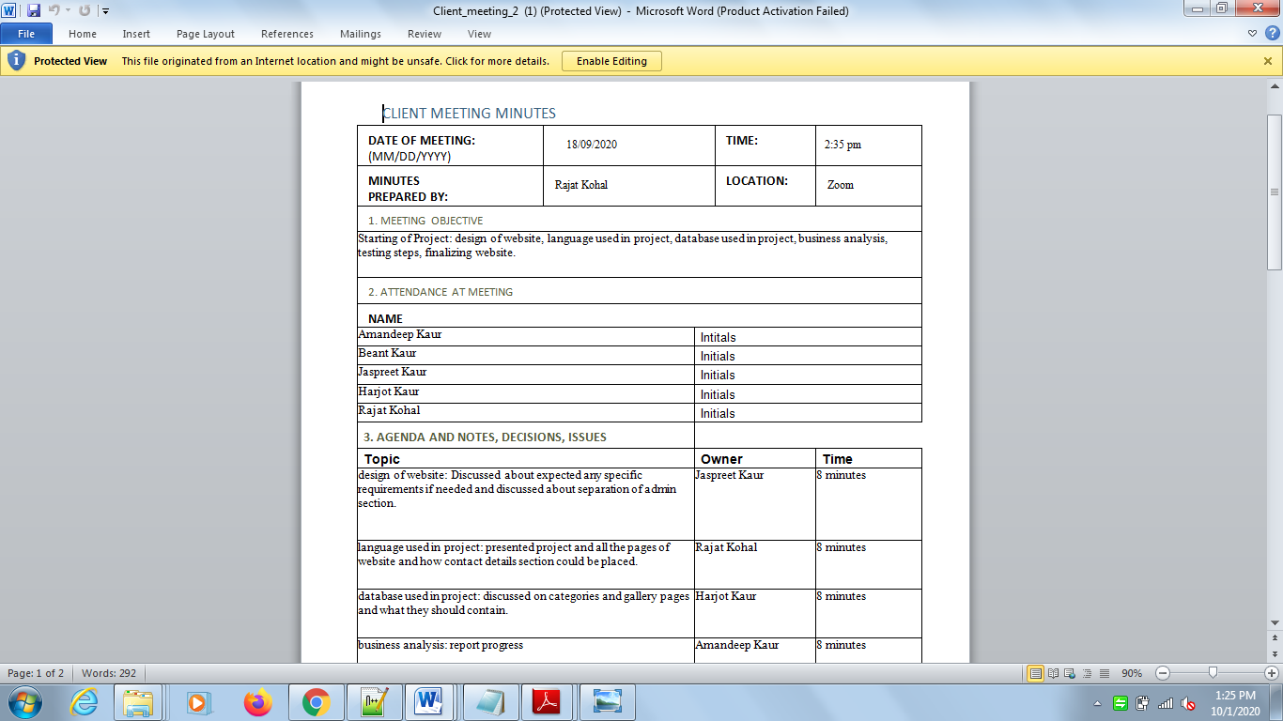

**Client Meeting Minutes -3**

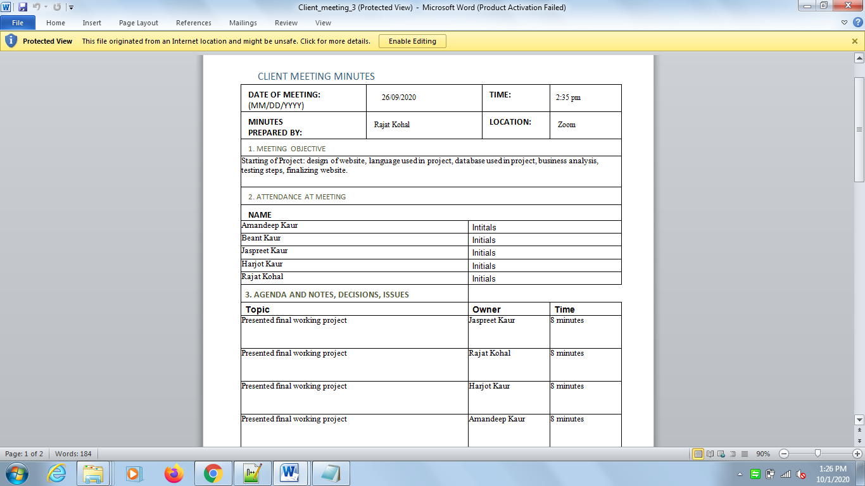

**Fix Meetings**

